|  |  |  |
| --- | --- | --- |
| C:\Users\randy\MyWebSite\astronomy\img\WinterSkyTour.gif | Winter Sky TourRandy Culp | [C:\Users\randy\MyWebSite\astronomy\winter.gif](file:///C:\Users\randy\MyWebSite\astronomy\index.html) |

The bitter chill of a clear winter night is compensated by the fire and brilliance of the sky above. No other time of the year offers so many bright stars and deep sky wonders so close together. This is where I started my first ventures into astronomy, 50 years ago, as a child with my Dad’s binoculars (which I still use) so these stars hold a special sense of distant nostalgia for me as well.

The winter sky is, of course, also the prime testing ground for all our new Christmas gifts.

The account here is the agenda that I loosely follow in providing a guided tour of the winter skies as visible from 45° North Latitude. This tour is designed for one topic to lead to the next, so it flows nicely and still manages to teach Astronomy under the night sky as we caravan from one constellation to another. Aside from the binoculars and telescopes I usually make a point of also bringing a highly focused flashlight which serves as an effective pointer for tracing out constellations.

Note that this tour is specifically designed to meet requirements 5, 7 and 8 (b) of the Astronomy merit badge, although of course there are lots of other tidbits here that go beyond the requirements of the badge.

Updated 14 April 2021

***View to the South***   
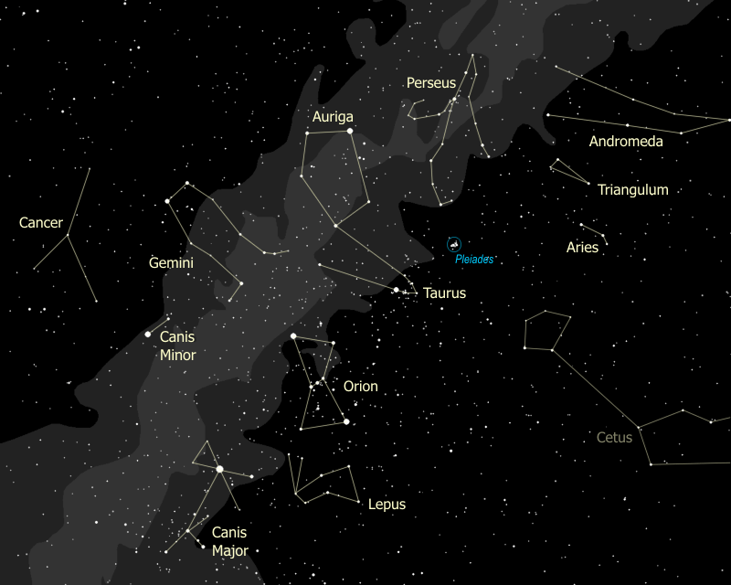

***View to the North***   
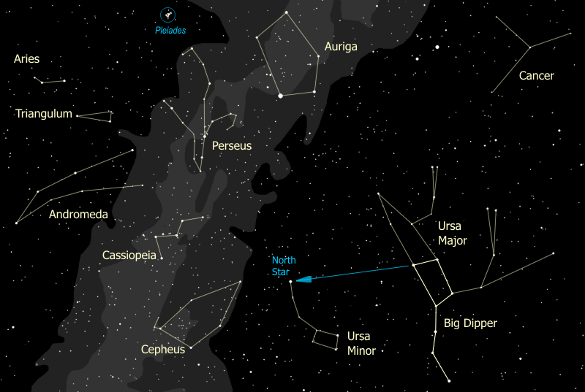

## Index to the Tour

C:\Users\randy\MyWebSite\astronomy\img\star.gif[Orion & Taurus](#_Orion_&_Taurus)   
C:\Users\randy\MyWebSite\astronomy\img\star.gif[Auriga](#_The_Constellation_Auriga)  
C:\Users\randy\MyWebSite\astronomy\img\star.gif[The Andromeda Legend](#_The_Andromeda_Legend)  
C:\Users\randy\MyWebSite\astronomy\img\star.gif[Perseus the Hero](#_Perseus_the_Hero)   
C:\Users\randy\MyWebSite\astronomy\img\star.gif[Ursa Major & Ursa Minor](#_Ursa_Major_&)  
C:\Users\randy\MyWebSite\astronomy\img\star.gif[The Zodiac Constellations](#_The_Zodiac_Constellations)  
C:\Users\randy\MyWebSite\astronomy\img\star.gif[Canis Major](#_Canis_Major)

## Overview of the Tour

The blue arrows map out the basic flow of the tour.

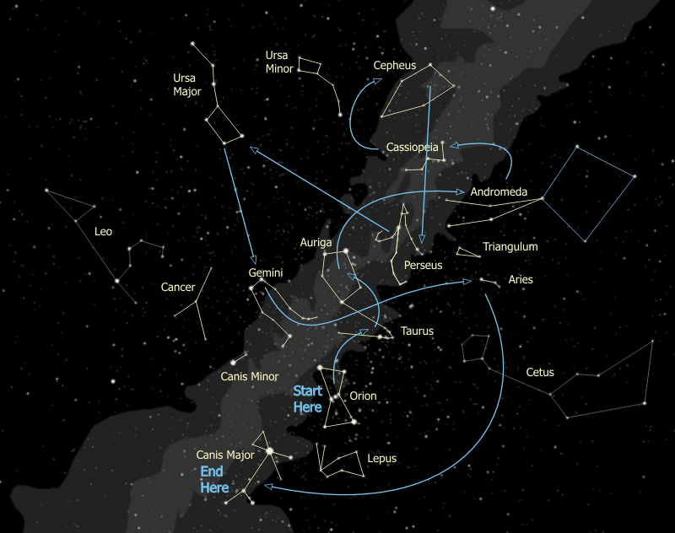

## The Top Attractions

As long as people can run in and out of the cabin to warm up, or if you have an especially hard-core gritty cold-resistant (i.e. native-born Wisconsin) group, the full winter tour is fine. Some nights, though, only the bravest will dash out to see what you have to show - quick quick quick. In that case, these are the best items to hit - the ones that the kids (and the adults) are talking about days later.

|  |  |  |  |
| --- | --- | --- | --- |
| **Feature** | **Naked Eye** | **Binoculars** | **Telescope** |
| The Great Orion Nebula |  | ✓ | ✓ |
| The Pleiades | ✓ | ✓ | ✓ |
| The Andromeda Galaxy | ✓ | ✓ | ✓ |
| γ Andromedae |  |  | ✓ |
| δ Cephei | ✓ |  |  |
| Algol the Demon Star | ✓ |  |  |
| The Double Cluster |  | ✓ | ✓ |
| Mizar & Alcor | ✓ |  |  |
| The Beehive | ✓ | ✓ | ✓ |

# Orion & Taurus

1. For touring the winter sky, our telescopes are set up and then are immediately trained directly on the Great Orion Nebula. So, now... as we all stare off to the south... who sees something they recognize? (Someone usually recognizes Orion.) This is the brightest constellation in the sky. Orion is a great hunter and mortal enemy of Scorpius, the Scorpion, which is why they are placed on opposite sides of the sky. In the late Spring, as we watch the last of Orion disappearing over the Western horizon, we can turn and watch the head of Scorpius peaking above the Eastern skyline to check that the coast is clear. When one rises the other sets, they are never seen together. {Trace out Orion, noting the belt, one raised arm holding a club, the other outstretched holding a pelt.}

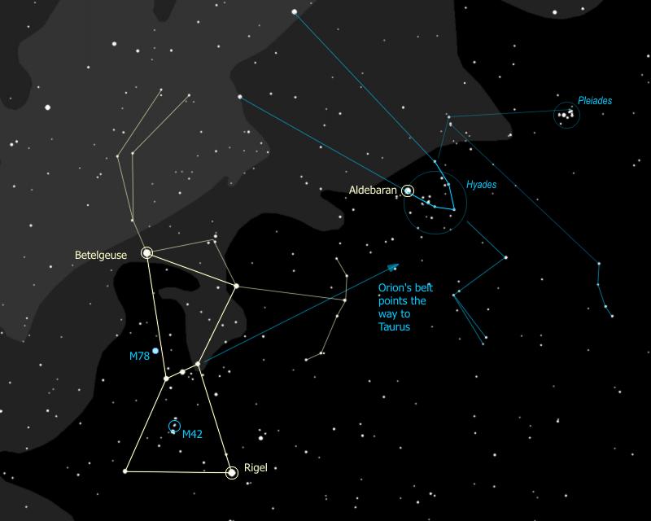

1. The two brightest stars have their own names. The one at Orion's shoulder, to your left, is Betelgeuse, pronounced "beetle juice", yes, like the movie, and the one at Orion's knee, to your right, is Rigel. Do you notice anything special about Betelgeuse? See how red this star is? It is actually a red super-giant star. This star is enormous. Placed where our sun is, the surface of Betelgeuse would reach to somewhere between the orbits of Mars and Jupiter. It is so big that we have been able to make an image of it and measure its diameter even though it is about 500 light years away.

There is only one other red super-giant that is this bright and it's on the opposite side of the sky, in the constellation that dominates the summer sky -- the star Antares in the constellation Scorpius. Both stars are about 500 ly away in opposite directions so we lie about halfway between the two. Such stars are rare -- there are only 200 known red super-giants and all are much dimmer, and therefore much farther away than these two stars.

1. Notice that there's a sword that hangs from Orion's belt. See how the tip of the sword gleams? That is not a trick of your eyes, there's something there, more than just a few stars. You can see it through binoculars, and you can see it better through the telescope.

|  |  |
| --- | --- |
| C:\Users\randy\MyWebSite\astronomy\img\m42_in_scope.jpg The Orion Nebula (M42) in a small telescope | C:\Users\randy\MyWebSite\astronomy\img\m42_FOV.jpg ...and in the Hubble Telescope |

1. This is the Great Orion Nebula, also known as "M42". It is one of many "M" objects named after a catalog published in the late 1700's by the Frenchman Charles Messier. Messier was a comet hunter of great renown who published a catalog of fuzzy things that might be confused with comets. These ended up being some of the most interesting objects in the sky.
2. This one is certainly interesting, isn't it? This is a "diffuse nebula"- a cloud of dust and hydrogen gas - the stars you see there were formed from the gas when it condensed together and compressed due to gravity then, under pressure, heated up and ignited. A nebula like this, then, is the birthplace of stars.
3. This region of the sky, Orion and its neighboring constellations, happens to be one that is dense with nebulae and young stars. The only other region of the sky with this much new-star formation activity is Sagittarius and its neighboring constellations.
4. This nebula is remarkably clear in a telescope, binoculars, or even to the fiercely concentrated eyeball. The longer you look, the more detail you can see. Notice in the telescope how the nebula forms the shape of a ghostly bat. Look very carefully at the bright star at the center of the nebula. It's not just one star, it is actually FOUR! In fact these four stars have a special name, they are called "The Trapezium". It is their energy that lights up the nebula.
5. The Great Orion Nebula is huge beyond comprehension -- what you are seeing is about 1500 light years away from us. The bright region you can see is about 5 or 6 light years across, however long-exposure photographs show that this nebula covers nearly the *entire constellation of Orion!*
6. Directly above M42, much smaller and almost touching, is another nebula, M43 (logically enough). A little above the two of them, a distance that's about the size of M42, is another nebula with the colorful name "NGC 1977". NGC stands for New General Catalog -- published in 1888 it's not really that new.
7. There's another nebula called M78, on the eastern side of Orion just above his waist. It's worth chasing down, and not too hard to capture in the telescope -- on a good night we can see it in binoculars. This is the brightest "reflection nebula" in the sky -- it is simply dust reflecting the light of those two stars you see in it. The Orion nebula, by contrast, is an emission nebula. The stars of the Trapezium are putting out such high-energy radiation, the gas is glowing on its own, like a neon light.

|  |  |
| --- | --- |
| M78 in Telescope | What you're looking at |
| C:\Users\randy\MyWebSite\astronomy\img\m78inScope.jpg | C:\Users\randy\MyWebSite\astronomy\img\m78noaoSmall.jpg |

1. You can extend the line of Orion's belt to the right toward a "V" of stars nearby. This is the face of Taurus the Bull. {Trace out Taurus, showing the face, the horns, and the two forelegs.} Some people try to fit the whole bull into the stars that are the legs and it comes out looking like something from a Picasso painting. That very bright star on the top left corner of the "V" is Aldebaran, pronounced "all-DEB-uh-ron".
2. 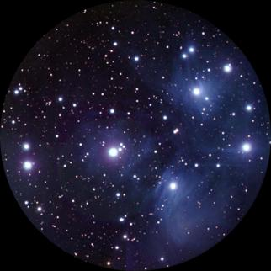See that little cluster of stars right about where the shoulder of the bull would be? That is the Pleiades, or the Seven Sisters. Can you count seven stars just by looking? Some people see six, some see seven. Actually you can find more than seven stars in binoculars and even more in the telescope. The better you can see this exquisite star cluster, the more beautiful it gets.

This is a true "galactic cluster", meaning a group of stars all born out of the same cloud of gas. Sometimes these are called "open clusters". In photographs of the Pleiades you can still see traces of gas around the stars, remnants of the original nebula. The Pleiades lie 400 light years away from us, with a total of 500 stars in the cluster. Nine are so bright they have their own names.

1. You want to see a star cluster that's three times closer than the Pleiades? The "Hyades" cluster is only 130 light years away from us. So where is the Hyades? It is the ENTIRE FACE OF THE BULL, with the notable exception of Aldebaran. Part of the reason that Aldebaran is so much brighter than the rest of the "V" is that it is only half as far away, at 65 light years. You definitely want to get a look at the face of Taurus in the binoculars. Wow, huh? The binoculars were worth bringing along just for that alone.

Usually a star cluster looks like a tiny fuzz ball, but the Hyades appears to be a huge and distinct group of stars spread out over the sky because it's so close. Like the Pleiades, the group consists of about 400-500 stars total. Also like the Pleiades, this is a true galactic cluster, born from the same cloud of gas and all moving together in the same direction in space. They are moving away from us, toward Betelgeuse, and in 50 million years they'll be just another little fuzz ball near that star. So enjoy it now while you can. The Hyades is estimated to be about 400 million years old, making it a fairly old star group for an open cluster.

By comparison the Pleiades are much younger, at "only" 100 million years old. Galactic clusters usually are relatively young, since events conspire to break these groups up over time. The sun has long since left the nebula and cluster of its birth, travelling now through the galaxy alone, with only us to keep it company.

# The Constellation Auriga

We're going to move up to the tip of Taurus' horns, to find some faint fuzzies trying to hide and to discover another constellation poaching one of those stars!

1. The star β (beta) Tauri marks the tip of the Bull's northern horn. This star is actually shared with another constellation, Auriga the Charioteer, which forms a bright five-sided figure. {Trace out Auriga}

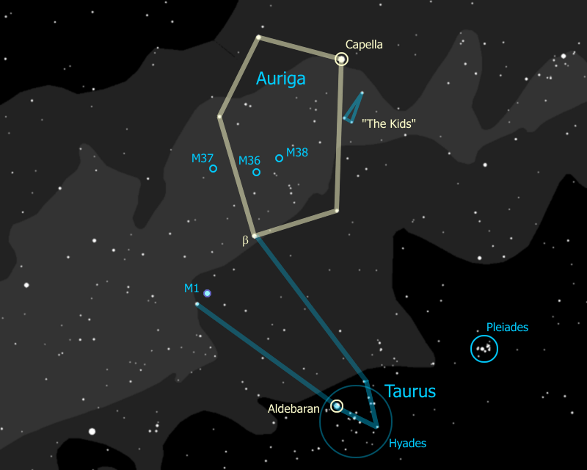

Auriga is often shown seated and holding a young goat in his arms, represented by the small thin triangle of stars along the right side of the pentangle. These stars are known as "The Kids". The star at the tip of this triangle is ε (epsilon) Aurigae. This is one of the brightest stars in our galaxy, a huge star 2,000 light years away which, every 27 years, is eclipsed by something even huger -- eclipsed for two full years.

The mystery of how this happens may have been solved very recently -- in January of 2010 the theory was presented that ε Aurigae is a dying star, with twice the mass of the sun and blown up to 100 times the diameter of the sun, whose outer shells are being blown off, captured, and formed into a disk by an orbiting companion star. It is this disk, which we are seeing edge on, that is periodically dimming ε Aurigae.

|  |
| --- |
| Artist's Conception of Epsilon Aurigae in Eclipse |
| C:\Users\randy\MyWebSite\astronomy\img\Epsilon_Aurigae_small.jpg |

1. The brightest star in Auriga is "Capella". Part of the reason it's so bright is because it's pretty close, 45 light years away. That makes it a little less than half the distance to the Hyades cluster. In fact, it is moving in space at the same speed in the same direction as the Hyades, and may be an "outlier" of that group. Another reason it's so bright is that it is really two stars orbiting one another, too close for us to see in the telescope. Capella is an important star for navigation because it's among the brightest stars in the sky, and because it's so far north that you can see it nearly all year round.
2. So what do you think, is Capella the brightest star in the sky right now? Do you see any stars you think might be even brighter? See that star way to the south? That star is Sirius, the second closest to our sun of all the naked-eye stars. (Only Alpha Centauri is closer.) Which is brighter, Capella or Sirius? Which do you think is brighter, Capella or Aldebaran? How about β Tauri, which is brighter, Aldebaran or β Tauri?

Astronomers measure star brightness using 'magnitudes' -- Capella has a magnitude of 0, Aldebaran has a magnitude of 1, β Tauri has a magnitude of 2. As magnitude number goes up, brightness goes down. A magnitude 1 is 2½ times as bright as a magnitude 2, a 2 is 2½ times as bright as a 3, and so on.

This comes from the system set up by ancient Greeks, where the brightest stars were stars of the first magnitude, like 'first class', and the faintest stars you could see were stars of the sixth magnitude. When astronomers got telescopes and instruments that could measure star brightness, they found 1st magnitude stars were almost exactly 100 times the brightness of 6th magnitude stars. That works out to a factor of 2½ from one magnitude to the next.

Magnitudes can go negative for stars brighter than 0 magnitude Capella. Sirius is the brightest star anywhere in the sky (any time of the year) with a magnitude -1.5.

Well, what's really the brightest star in the sky? The sun has a magnitude of -27.

1. It's not only the brightness of each star that is different. Look at Betelgeuse and Rigel. Can you see a difference in color between these two stars? Betelgeuse is red, and Rigel is more blue. Look at Capella and tell me what color that might be. It's more of a yellow color, isn't it? How about the stars of Orion's belt? Those stars are really blue, aren't they? You can see the colors even better when you examine the stars in binoculars or a telescope. So what do the star colors mean? Why would one star be blue and another red?

Yup, that's right. Different colors show different temperatures. So which star color is the hottest? Just like a flame, blue is the hottest part, yellow is next, red is the coolest. The sun is a yellow star, about 10,000°F at the surface. A red star is about half the sun's surface temperature, whereas a blue star is three to five times as hot as the sun. White stars like Sirius are somewhere between the yellow ones and blue ones.

Now, all stars are made of pretty much the same stuff -- about 90% hydrogen and the rest is helium with some traces of other stuff. So, why would one star be burning hotter than another? The answer is in the size of the star. The more massive it is, the more pressure there is at the center and therefore the hotter - and for that matter the brighter - the star burns. So blue stars are the biggest and brightest of stars, and red stars are the smallest and dimmest.

So why is red Betegeuse so bright? Hmmm... yeah... well, like with most rules, there are exceptions to the rule, and this rule is no exception. Betelgeuse is a star that is literally running out of gas. As a star burns up all the hydrogen at its center, it starts to burn helium (which is the "ash" from the hydrogen burning), which makes it expand, get brighter, and turn red -- it becomes a red giant. This is the time you can get a bright red star, when the star is near the end of its life.

When our sun starts burning out it will expand so big it will swallow up Mercury and Venus and scorch the surface of the earth to a cinder. If you are hoping to see all that happen you will have to wait about 5 billion years.

So there are two reasons a star could be red -- it is massive (and once was yellow, white or even blue) and is now burning out (a red giant), or it never had enough mass to burn any hotter than red (a red dwarf).

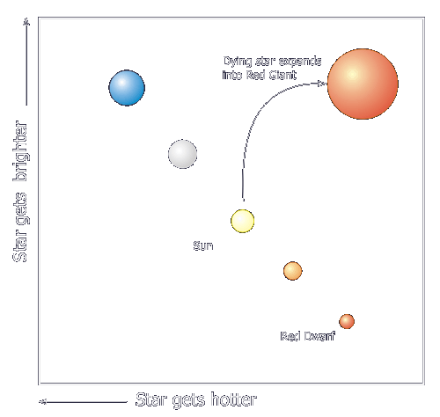

Notice that when we graph out the stars showing their temperature (or color) against their brightness, most of them fall along a line -- this line is called the Main Sequence, and the graph is called the "H-R" (for Hertzsprung-Russell) Diagram. Others are not on the main sequence, mostly stars that are either just being born (called "T-Tauri" stars) or stars that are near the end of life.

1. Now even though it is a red super-giant near the end of its life, Betelgeuse is actually a very young star, at least compared to the sun. Betelgeuse was born only about 6 million years ago, long after the Dinosaurs died out, and is nearly at the end of its life already. This is because Betegeuse is so much more massive than the sun. The greater mass causes greater pressure and forces the star to burn hotter (bluer) and faster.

So Betegeuse was once a blue supergiant with 15 times the mass of the sun, burning 60,000 times as fast as the sun, and looked a lot like Rigel does today. Its life as a star will be less than one thousandth as long the sun will live (the sun, and the very earth you're standing on, are nearly 5 BILLION years old and our sun is good for about another 5 billion years). With stars, the bigger they are, the harder they fall.

Betelgeuse is so big we can measure its size even at 600 lightyears away. Moreover, since 1993 it has gotten 15% smaller, so there is now speculation that it might go supernova in the next few years. If that turns out to be right, and since its light takes 600 years to reach us, that would mean that Betelgeuse has already exploded!

1. Note - we might have the following discussion any time during the sky tour, whenever it comes up.

Auriga lies right across the Milky Way and therefore contains lots of interesting stars and star clusters. Someone want to tell me what that means -- "The Milky Way"? Where is the Milky Way (someone will always point it out). Most people recognize the Milky Way as a band of light across the night sky, but what is that band of light - where does it come from?

Well it's a bit like looking at a gravel road. Close to you, you can see individual stones, while off in the distance the road merges into a uniform gray. When you look at the Milky Way you are looking at the disk of our galaxy from the inside - the nearby stars you can see individually (most are less than 1,000 light years away), the distant stars merge into a hazy glow. So when you see that band across the sky you are really looking way off into the distance, into the "billions and billions" of stars that make up the disk of our galaxy.

You'll see a similar phenomenon when we look at the more distant galactic clusters. Through binoculars you see them as a hazy patch. When you see them through a telescope - that is, closer up - you can pick out individual stars. The better the telescope, the 'closer' you can get to the cluster, the more stars you can see.

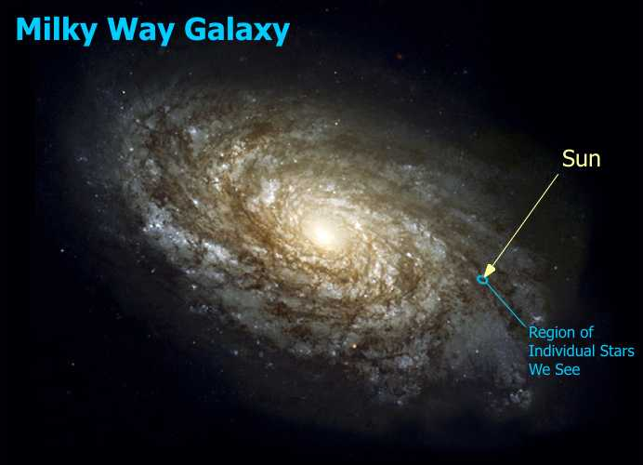

1. Let's look for some of those faint fuzzies. We can see them as little fuzzballs in the binoculars, and they get more interesting if we can get the telescope on them.

M36 is found just inside the center of eastern edge of the five-sided figure of Auriga. This is a galactic cluster just like the Pleiades, and would look a lot like the Pleiades to us, except that it is 10 times farther away. The Pleiades is at a neighborly 400 lightyears distance, M36 is waving at us from 4000 lightyears away. Notice though, how, like the Pleiades, this is a group of all bright blue stars, and like the the Pleiades, it is very young (~25 million years old).

To the right of M36, within the same binocular field of view, is M38. In the telescope, if you stare hard, you can see a cross shape to this cluster. Can you spot the yellow giant among the younger, blue stars? The giants, stars which are reaching the end of their life, are used to determine the age of the cluster - the fewer blue stars, the more red & yellow giants, the older the cluster. M38 is quite a bit older than M36, at about 200 million years.

To the left of M36, just outside the eastern edge of Auriga, is M37. This is a large and colorful cluster with many older stars and hence is older still than M38, at about 300 million years. This cluster is considered to be the finest and most beautiful of all galactic clusters. All three of these clusters lie at about the same distance away, 4000 light years, and are estimated to have about a 100 or so stars.

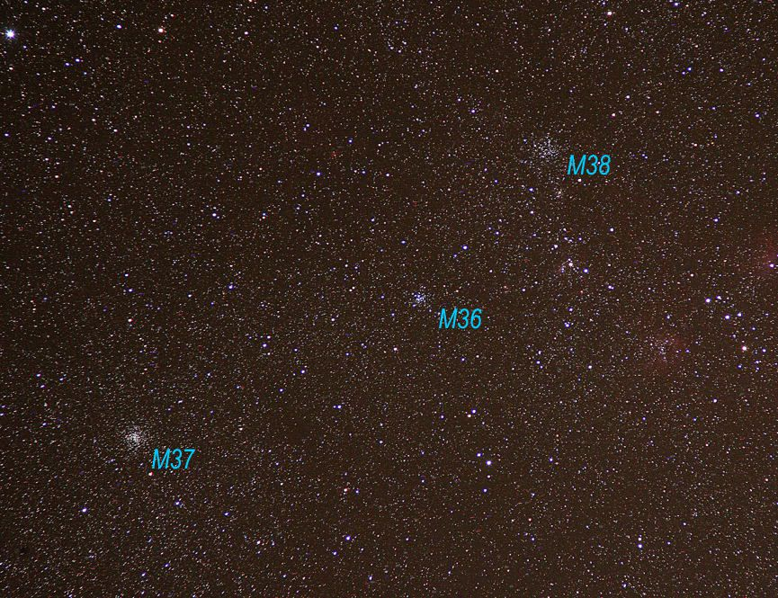

1. Assuming it's an extra-clear, dark night and you've checked that you can see the Crab, or if you have a highly serious group, you can go after this important astronomical landmark. Otherwise skip this part or mention it in passing. Even on a good night it's tough to see.

We will now move to the tip of the southern horn of Taurus, the star known as ζ (zeta) Tauri. Almost exactly one degree to the northwest of ζ Tauri we will find another faint fuzzy patch. This one we cannot resolve into individual stars, no matter how much magnification we put on it.

The designation on this object is "M1", the first item in the Messier catalog, commonly known as the "Crab Nebula". This was the object that originally inspired Charles Messier to make his famous list, because he confused it with a comet until he realized it was not moving.

|  |  |
| --- | --- |
| Crab Nebula in Telescope | What you're looking at |
| C:\Users\randy\MyWebSite\astronomy\img\CrabInScope.jpg | C:\Users\randy\MyWebSite\astronomy\img\CrabNebula.jpg |

What you are actually looking at is the rapidly expanding cloud of gas that used to be a star until it exploded in a supernova in the year 1054. According to historical records the supernova was so bright you could see it during the daytime for nearly a month. In a high-powered telescope you can actually see filament structures which to one early astronomer looked like the legs of a crab, hence the name. The gas cloud is expanding at 1,000 miles a *second!*

At the center of this gas cloud is a neutron star, with a mass equivalent to our sun in a ball 20 miles across (the sun is 800,000 miles across) and spinning at 30 times a second. It is a pulsar and a radiation monster. It is a strong radio source and also a bright X-ray source (and everything in between), putting out 100,000 times more energy than the sun.

We are looking at it from the safe distance of 6300 light years away. If the original supernova had been closer to us, say, as far as Capella, the radiation from the blast would have wiped out all life on earth. On the other hand, in a huge cosmic irony, we wouldn't be here at all if it weren't for supernovas like this one. The universe is made up only of hydrogen and helium, all the heavier elements, like the ones we are made of -- carbon, oxygen, iron, the calcium in our bones, are all created in supernova explosions.

So technically speaking, you are stardust.

# The Andromeda Legend

Let's go hunt for a galaxy... if it's a good, clear night you can see this one just by looking -- which makes it the farthest thing you can see with your eyes, at 2 MILLION light years away.

1. To find it we start with the Great Square of Pegasus. The Great Square is formed by these four stars here {trace out Great Square} and Andromeda's head is the Northeast (upper left hand) corner star. The rest of Andromeda is then the figure formed by the two curved lines that radiate Northeast away from that corner {trace out Andromeda}.

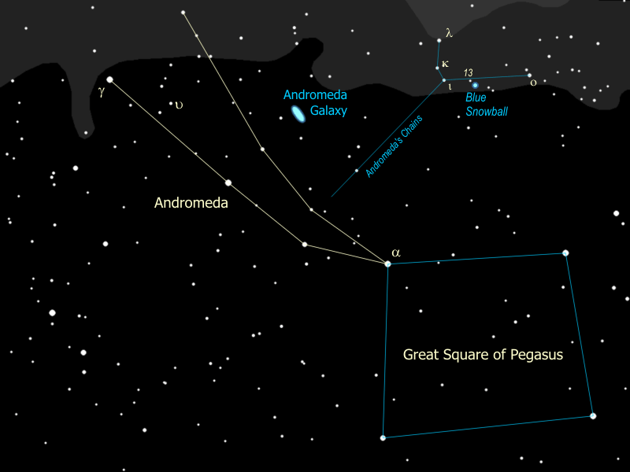

1. Now let's find the Andromeda galaxy. Start with Andromeda's head, then go to the next pair of stars, then to the next pair of stars after that (a little further apart). Follow the line of that pair up and to the right (Northwest) until you get to the next star. Look for a little fuzzy patch just to the right of that star. It sometimes helps if you don't look straight at it, but just off to one side a little bit. When you spot it, just note that you are seeing far beyond our own galaxy, 2 million light years away.

You need a good, dark sky to see the galaxy by eye, but it is easy to find in binoculars. In fact, it looks best in a good pair of binoculars, 10x50 or bigger. It is also an easy target for the telescope. If you look hard in the telescope you might see one or two smaller fuzzy patches near Andromeda. These are satellite galaxies, little galaxies orbiting the big one! Our galaxy, the Milky Way, has satellites of its own, called the Magellanic Clouds. They can be easily seen, looking like detached portions of the Milky Way, but they can be seen only in the Southern Hemisphere.

|  |  |
| --- | --- |
| Andromeda in Telescope | What you're looking at |
| C:\Users\randy\MyWebSite\astronomy\img\AndromedaInScope.jpg | C:\Users\randy\MyWebSite\astronomy\img\andromedaTimMatheson_c2003.jpg |

1. We'll swing the telescope real quickly over to the star at Andromeda's left foot (the Southeast one), γ (gamma) Andromedae {point out γ Andromedae}. This is a double star -- can you see the color difference between the two stars? The bright one is yellow-orange, the other is a bluish-green. This is one of the coolest looking doubles in the sky. It's a true double star -- actually it's a four-star system, the blue one is really three stars, but they're too close together for our telescope.

Another star of interest is υ (upsilon) Andromedae, a star very similar to our own sun {point out υ Andromedae}. In 1999 three planets were shown to be orbiting υ Andromedae, making this the first system of planets to be discovered outside our own. (We can't see the planets in our telescope - they were found by calculation from the motion of the star).

1. Andromeda is a princess and she is shown chained to a rock, by her daddy the King. And it wasn't even for anything that *she* did, but we'll get to that in a second. If you follow the chains up to the rock {formed by λ, κ, ι & ο Andromedae, point out the rock} right next to that little bitty star right there {point out 13 Andromedae} is where we are going to focus the telescope. When you look in the eyepiece you'll see two stars and something else... a puff of smoke, maybe. Compare the little puff to the two stars next to it. Can you see a color difference? The puff is actually blue, or blue-green. In fact is known as the Blue Snowball. It's a star like the other two that you see, but this star has blown itself apart!

|  |  |
| --- | --- |
| Snowball in Telescope | What you're looking at |
| C:\Users\randy\MyWebSite\astronomy\img\Snowball_In_Scope.gif | C:\Users\randy\MyWebSite\astronomy\img\NGC7662.jpg |

1. This is called a "planetary nebula", because the disk shape suggested the look of a planet to early astronomers. In fact it has nothing to do with planets at all. This is what's left of a red giant star that finally did what all red giants eventually do. When the fuel at the core runs so low that the nuclear reactions can no longer hold up the weight of the star, it all collapses in to the center, which in turn raises the temperature so high that the star blows off its outer envelope of gases, losing much of its mass. This exposes the core to outer space, or, more accurately, exposes outer space to the core. The intense radiation from the white-hot core causes the expanding shell of gas to light up like a neon light, and voila -- the faintly glowing disk that you see here. With a larger telescope you can still see the tiny star that remains at the center of the Blue Snowball -- now a white dwarf.
2. So a planetary nebula is completely different from a [diffuse nebula](file:///C:\Users\randy\MyWebSite\astronomy\Winter\OrionTaurus.html#Diffuse) like the one we saw in Orion. The Great Orion Nebula is the birthplace of many new, brightly shining stars. By contrast a planetary nebula is the deathbed of a single star, fading to a white dwarf. (Note that a planetary nebula is also subtly different from the Crab Nebula which is a supernova remnant -- much larger, much more violent, and with a neutron star at the center instead of a white dwarf). A few billion years from now, our sun will look a lot like the Blue Snowball.
3. So how did Andromeda end up chained to a rock? It all started with her mother, the Queen Cassiopeia. Does anyone know how to find Cassiopeia? (Very often someone will). That's right, Cassiopeia is a Big W on the opposite side of the North Star, Polaris, from the Big Dipper. We'll come back to the Big Dipper in a little while. At this time of the year Cassiopeia is upside down so now it's a big "M" instead of a big "W". Notice that once you've found it, you can zero in on Polaris, as the center peak of the "W" points in the general direction of the North Star.

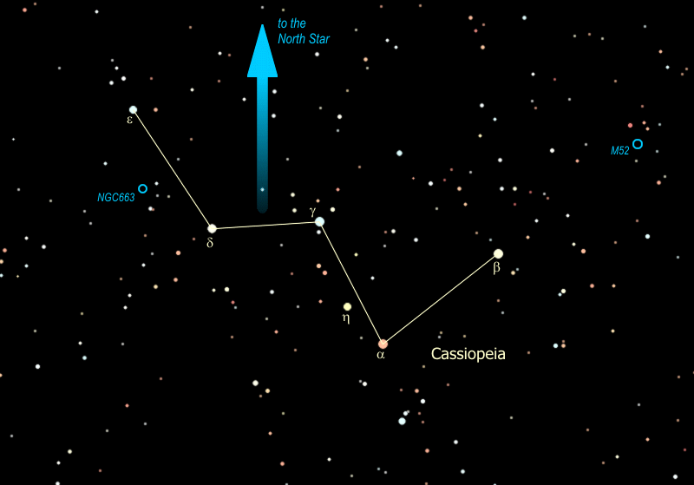

1. The constellation Cassiopeia lies right smack in the middle of the [Milky Way](file:///C:\Users\randy\MyWebSite\astronomy\Winter\Auriga.html#MilkyWay), and is filled with open clusters, like M52, a "young"cluster of about 200 stars -- young means that it is only about 100 million years old. The cluster is 10 light years in diameter and 3000 light years away from us, which is why you need the binoculars to see it.

Another interesting galactic cluster is NGC 663 This cluster lies about half way between the two stars on the flattened side of the "W", e and d Cassiopeiae. As you sweep the binoculars between the two stars, you will notice that NGC 663 is merely the largest and brightest of several clusters in this region. That may be because it is the closest, at about 3000 light years. The others in that area are 6000 - 8000 light years away. How many clusters can you spot between these two stars? You might be able to see as many as five, with NGC 663 at the center and the other four marking the corners of a diamond around it.

|  |  |
| --- | --- |
| M52 - Note the little box of stars around the cluster | NGC 663 - halfway down the left side of the "W" |
| C:\Users\randy\MyWebSite\astronomy\img\M52.jpg | C:\Users\randy\MyWebSite\astronomy\img\NGC663.jpg |
|  |  |

1. So Cassiopeia had a reputation far and wide for her beauty, and that was not enough for her. She started going around boasting that she was more beautiful than the Nereids, the sea nymphs. When the Nereids caught wind of this they complained to Poseidon, god of the sea, who sent a huge sea monster, Cetus, to wreak havoc in the kingdom Godzilla-style. You can just see Cetus on the western horizon at this time of the year {trace out the head & body of Cetus} -- pretty terrifying, huh?

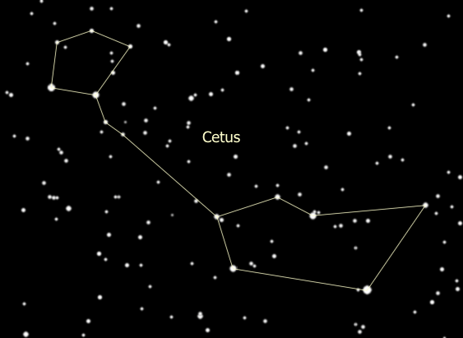

1. All of which brings us to Cepheus the King -- Cassiopeia is his queen, and Andromeda is his beautiful daughter. Cepheus is a house-shaped constellation very close to the Northern horizon at this time of the year. {Trace out Cepheus}.
2. This constellation contains the reddest star in the sky, μ (Mu) Cephei, also called "The Garnet Star" and is located halfway between the two stars at the bottom of the house. It is a red super-giant, 1,500 times the size of the sun. It was considered the largest star known to man until just recently when 3 other stars (which you can't see without a big telescope) were measured about the same size but just barely edge it out. Placed where our sun is, the surface of μ Cephei would extend out past Jupiter. If you are ever on an expedition to the planet Mars, you might want to know that μ Cephei is the pole star for Mars.

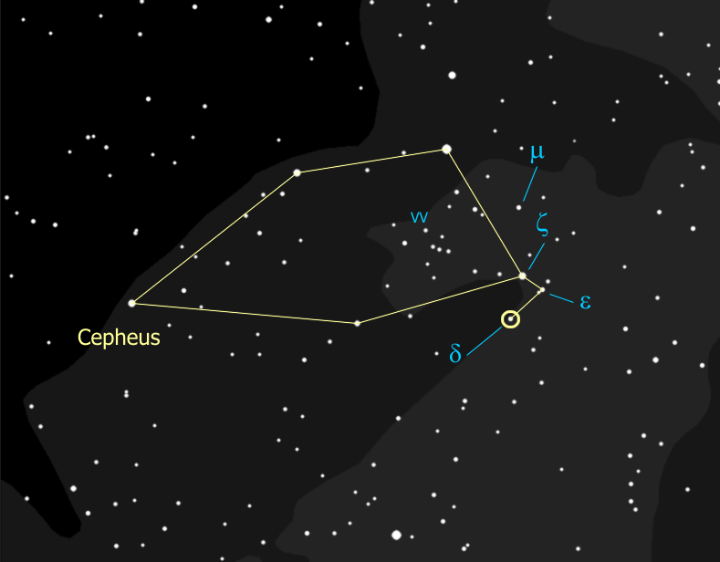

1. Another star in Cepheus is of crucial importance to astronomy -- δ (Delta) Cephei. {Locate δ Cephei.} This star is a "variable", meaning the star's brightness varies over time -- in this case it varies between that of ζ (zeta) Cephei and ε (epsilon) Cephei over a period of five days. How bright is it now -- as bright as ζ, ε, or in between? We will assess again each night that we can during the week.
2. This star was the first of its type to be discovered, hence these variable stars are called 'Cepheid' stars. Cepheid stars have gotten to just the right mass to be unstable - so the whole star is pulsating, the surface of the star is actually rising and falling, with a rhythm that is so precise you could set your watch to it. It was discovered in 1912 that this rhythm depends directly on the true brightness of the star -- the brighter the star, the longer the time between peaks. This discovery, as it happens, rocked the astronomy world. So why was this such a big deal?

Well when a star is closer to us, it seems brighter. When it's farther away it seems dimmer, right? And we know the true brightness of a Cepheid star, from the cycle time of its brightness. If we know the true brightness of the star, and we measure its apparent brightness, we can figure out the distance to the star. If the star is part of a cluster or a galaxy, this tells us the distance to that entire body of stars. This has been used to find the distances to globular clusters, other galaxies and even our distance from the center of our own galaxy -- 28,000 light years.

In 1924, Edwin Hubble (yes, the telescope is named after him) used Cepheids to measure the distance to the Andromeda 'nebula' (2.3 million lightyears) and proved that it is not another solar system in formation but an 'island universe', another galaxy like our own. This was an extraordinary declaration about the structure of the universe back in 1924. Our whole system of measurement of the universe is built upon the Cepheids as our basic yardstick.

1. Then on top of all that, if we look in the telescope we can see that bright yellow δ Cephei has a beautiful blue companion -- so this is both a variable star and a binary! The yellow star is the variable component, and once was a blue star like its companion. It is now expanding out as it goes through the end-of-life process, and is passing through an unstable phase as it does so. The pair is about a thousand light-years from us, based on the Cepheid period-brightness relationship.

Meanwhile, back in the kingdom, we left Cetus tearing things up, and Cepheus, as the local King, is presiding over this disaster. He consulted his oracle to determine what to do, and the oracle told him that the only way to appease the angry sea god was to sacrifice his daughter, that would be Andromeda, to the sea monster. Sadly, the king chained up his daughter to the rocks by the shore to await the arrival of Cetus.

So here we have them all -- Cepheus the King in a jam, Cassiopeia his beautiful if not terribly bright queen, Andromeda his lovely daughter chained to a rock, and here comes Cetus lumbering like Godzilla with devastation in his wake and our poor little princess in his sites! Are they all going to just sit there watching? Won't somebody DO something?

# Perseus the Hero

Ah, here he comes, the guy we've all been waiting for, the hero of our story, the one, the only -- **Perseus!!**

1. You can find Perseus at Andromeda's feet, and just off the squashed side of Cassiopeia's "W". The triangle that forms his head, though of modest brightness, is an easy feature to recognize, then the rest of the figure, which is pretty bright, is easy to follow from there. {Trace out Perseus}. His right arm is holding his shield, and in his left hand he has the head of Medusa the Gorgon. Being a man of action, he comes directly from his triumphant victory over Medusa and stumbles upon Andromeda, soon to be in the clutches of Cetus the Seamonster.

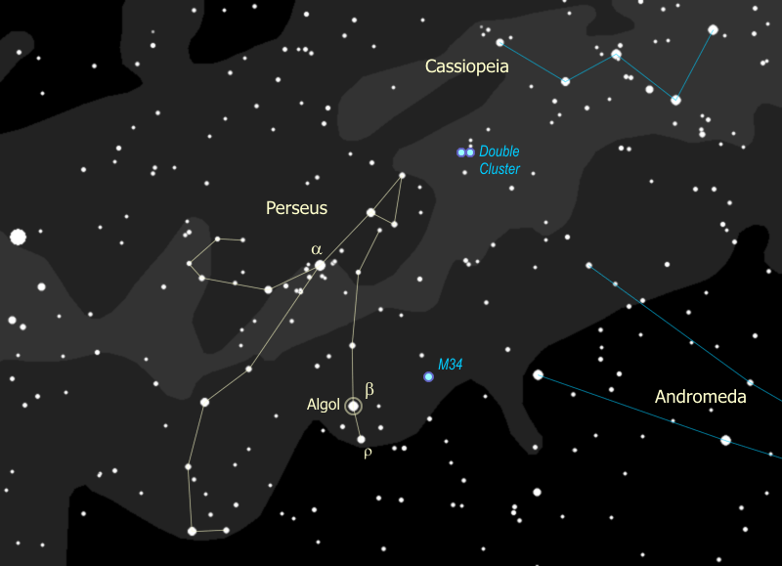

1. The eye of Medusa is well-represented by the star Algol {point out Algol}. Since ancient times Algol has been called the "Demon Star", and in fact the name means "head of the demon". Why? Because this star winks at you. Since stars aren't supposed to do that, it kind of gave people the willies long ago, and they figured it had to be evil or posessed or in some other way just wrong. Normally Algol is nearly as bright as α Persei {point out α}, almost exactly as bright as γ Andromedae. Sure enough, just about every 3 days Algol drops in brightness to that of ρ Persei {point out ρ}. It stays like that for a few hours then goes back to being as bright as α. Any guesses why something like this might happen?

Algol is actually a binary star, and the orbit of the two stars is right in line with us, so each time one star passes in front of the other, the second one is blocked and we see only half the light. This is called an "eclipsing binary". This is not the same as a [Cepheid variable](file:///C:\Users\randy\MyWebSite\astronomy\Winter\Andromeda.html#Cepheid), where the star itself is changing. So what do you think -- is Algol in eclipse right now? We will check on it again when we get the chance and see if we can spot the change.

You might remember Medusa, she was a Gorgon, a monster with snakes for hair and so ridiculously ugly that anyone who looked at her would turn to stone. So how do you suppose Perseus saved Andromeda? That's right, he showed Medusa's head to Cetus, who promptly turned to stone and the princess was saved. Lucky he just happened to have that head on him, not usually something you carry around.

1. If it seems to you that there are an awful lot of stars around α Persei that's because there are... that is a true glactic cluster of stars, all formed together, and they look spectacular in binoculars at the relatively close distance of about 600 light years. You can spot another cluster in Perseus half way between Algol and γ Andromedae -- an easy target for binoculars and with a really dark sky, one you should be able to spot just by looking. This is M34, about 1500 light years away and very similar in nature to the Pleiades or M36 in Auriga. M34 is about the same age as these other two at about 100 million years.
2. But the best cluster in Perseus is really two clusters, the Double Cluster halfway between Perseus and Cassiopeia. You can find it easily in the binoculars even though it's about seven thousand light years away, and this is definitely worth getting in the telescope. The one closer to Cassiopeia called "h Persei" and is "only" about 3 million years old. The one closer to Perseus is called "χ (chi) Persei" and is 6 million years old. How can you tell that χ Persei is older? If you look at it carefully in the telescope you might be able to spot three red giants in χ Persei, whereas h Persei has no stars old enough to have evolved yet into red giants.

|  |
| --- |
| Double Cluster with χ Persei to the left and h Persei to the right |
| C:\Users\randy\MyWebSite\astronomy\img\doubleCluster2.jpg |

# Ursa Major & Ursa Minor

1. So we were just looking at the Big "W", Cassiopeia, which is a polar constellation -- one that is very close to the North Pole. If stars are close enough to the pole they never set below the horizon and we can see them all year long. Can anyone spot the Pole Star? How do you find it? That's right, you start with the Big Dipper. {Trace out the Big Dipper}.

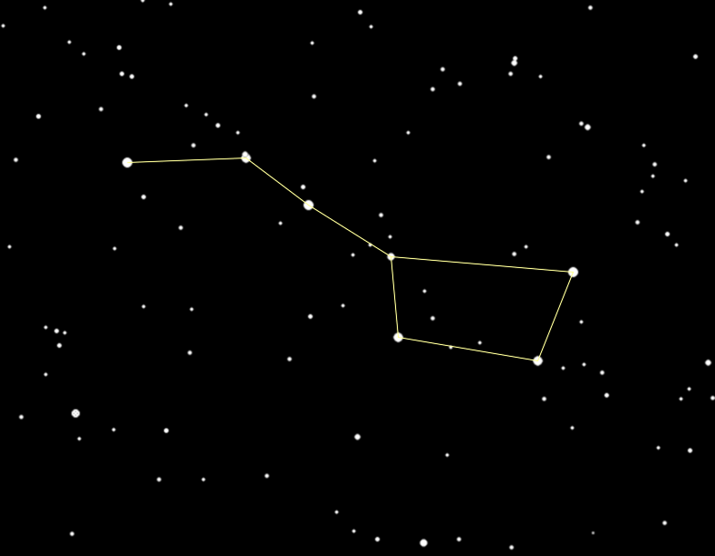

1. It's really not a constellation, it's what's called an 'asterism', a highly recognizable part of a constellation. The full constellation actually is Ursa Major. {Trace out the full constellation of Ursa Major}
2. The Bear's paws are also known as the Three Leaps of the Gazelle. This asterism is the sequence of three pairs of stars - normally seen as the paws of Ursa Major. The story is that Leo the Lion startled a gazelle, who in turn dashed off across a great celestial pond, leaving a pair of stars marking each of the three leaps.

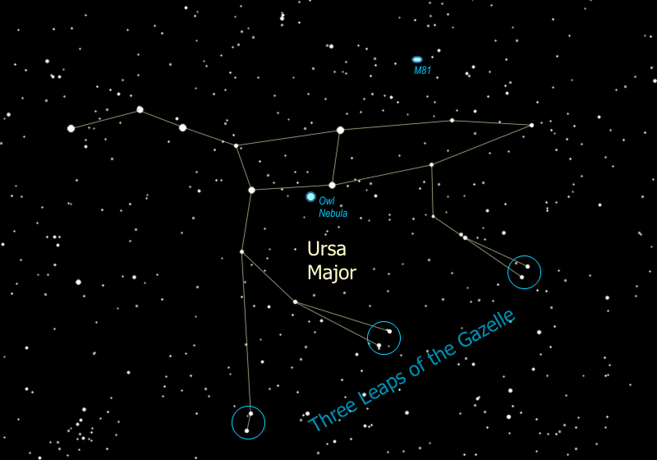

1. We can find two of the best and brightest galaxies in the sky just above the two stars that form the neck of the Bear -- they are M81 and its neighbor M82. Use the binoculars and follow the line of the Bear's neck to a skinny triangle, then go sideways to find a pair of stars that point the same direction as the triangle does. Just a little farther you find M81, a faint fuzzy spot just off the end of the arc of three faint stars nearby. See it? This faint fuzzy spot is actually a spiral galaxy, 12 MILLION light years away. When I get this one in the telescope you'll see that there are actually two galaxies there. The other one is M82, and it's called the Cigar Galaxy because of its shape -- it looks flatter than M81 because we're seeing it edge-on. M82 is about the same distance as M81, and is called a "starburst galaxy", because the gravity from M81 is causing a burst of new star formation in the Cigar. So even though M82 is only about a third the size of our Milky Way galaxy, it is five times brighter!

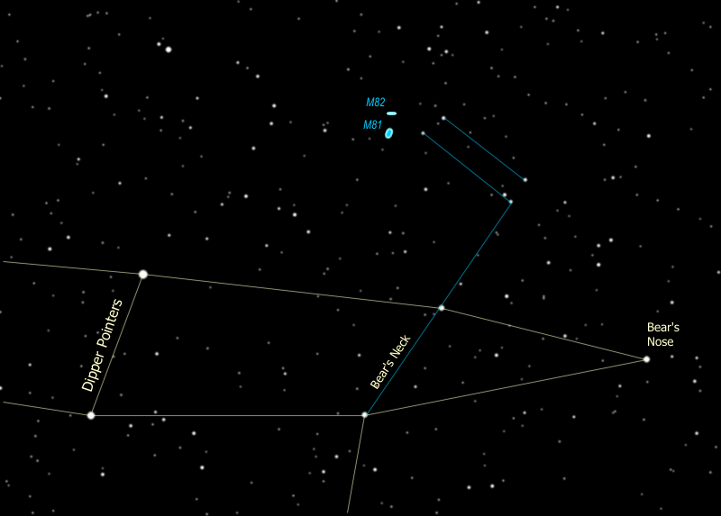

|  |
| --- |
| M81 is on the left, M82 is at the right |
| C:\Users\randy\MyWebSite\astronomy\img\m81m82.jpg |

1. The Big Dipper is the most important constellation (asterism) for you to know -- it points you to important reference stars so from there you can find your way around the sky.

The Pointer Stars of the Big Dipper are the two at the front edge of the cup -- go up from the cup to get to the North Star (Polaris).

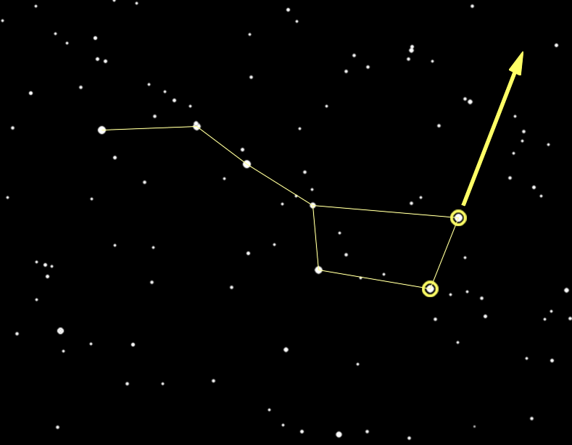

1. Since the earth's north pole points to Polaris and the earth rotates around its poles, all the constellations seem to rotate around Polaris, including the Big Dipper. You can tell time using the Big Dipper -- it serves as a 24-hour clock.

Click on the little clock [here [C:\Users\randy\MyWebSite\astronomy\img\tt32.gif](#_Tell_Time_by)](#_Tell_Time_by)for more information.

1. Polaris is a part of the constellation Ursa Minor, more commonly known as the Little Dipper. Polaris is at the tip of the handle. {Trace out the Little Dipper.}

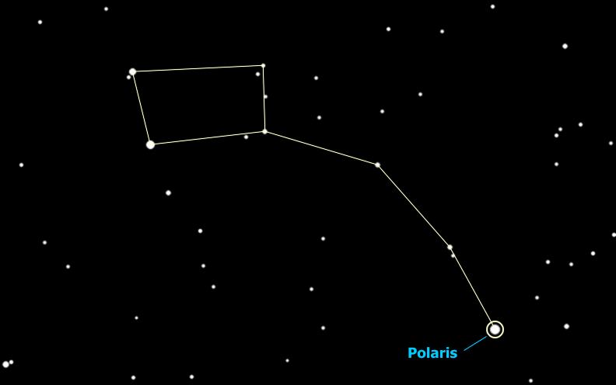

1. So the Big Dipper points to the North Star -- it also points to other important stars -- you follow the two stars across the top of the cup and they lead you to... hey look at that, it's Capella (in Auriga). If, instead of going up from the front of the cup, you go down from the back of the cup, you end up at the star Regulus in the constellation Leo. And... if you go across the cup, from the back top to the bottom front, you end up at Castor in Gemini, which is where we are going next. You can continue that line on until you get to Betelgeuse in Orion.

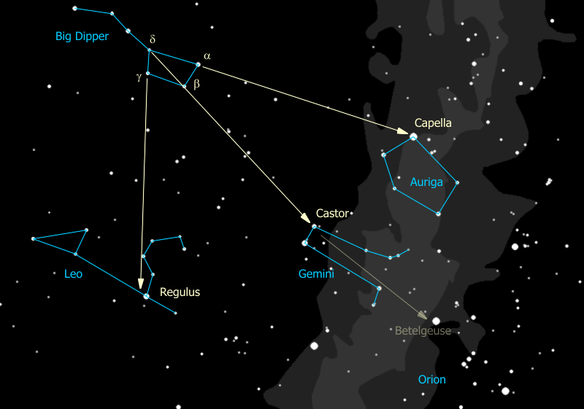

1. The three stars of the handle are pointers as well, but the stars they point to, while important, are below the horizon right now. Wait a minute is that really three stars in the Dipper's handle or is it four? Looky there the middle star seems to have a companion -- the bright star is Mizar and the companion is Alcor. Who can see the companion?

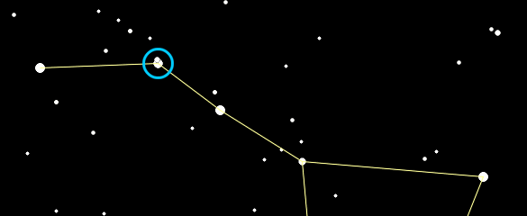

That was used by ancient Greek and Arab armies as an eye test. Some see them as a horse & rider. The Europeans saw the handle of the dipper as the tail of the Great Bear. Since bears don't have tails they danced around it by explaining that when the gods lifted the bear to the sky the tail got stretched out. Pretty lame. The Indians, who knew darn right well that bears don't have tails, saw the three stars of the handle as hunters chasing the great bear (interesting that they also saw a bear). When the constellation Ursa Major sets in the fall, the Indians explained that the hunters catch up with him and shoot him with their arrows, which is why the leaves on the trees turn red. Anyway the three stars are hunters and one of them brought his dog, so Mizar is a hunter and Alcor is his dog. Or another story is that there are three hunters pursuing the bear and one brought a pot to cook the bear in (optimistic). So Mizar is a hunter and Alcor is his pot. Yet another story involves the Pleiades. They are sometimes called "the Seven Sisters" and those with very sharp eyes can see seven stars but most people can only see six. So the story is that Mizar is riding off with the Seventh Sister.

But wait there's more! When we put the telescope on these two you'll see that Mizar is really a double star itself! So these three form a triple star. But wait... that's right... there's MORE! In reality each of the two stars that make up Mizar is a double star, too close for us to see even with a big telescope, and for that matter, so is Alcor! So Mizar & Alcor comprise a SIX STAR SYSTEM!!

# The Zodiac Constellations

1. We now follow the line diagonally through the dipper to the star Castor. This is part of the Zodiac constellation Gemini the twins. The two brightest stars are Pollux, to the left, and Castor, to the right. {Trace out Gemini}.

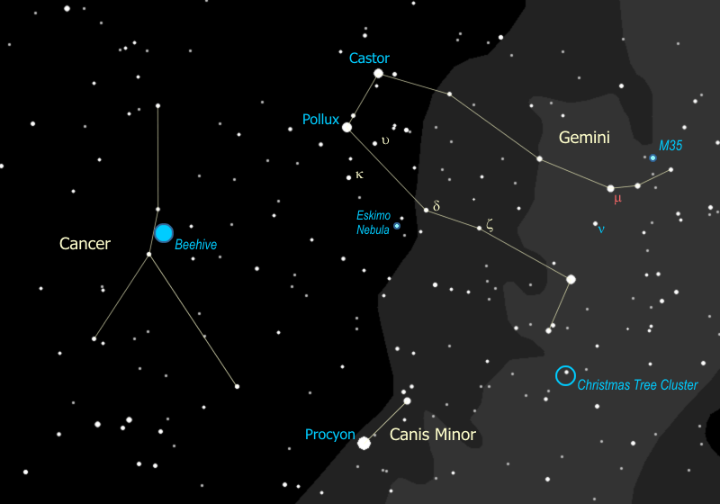

1. That really bright star right next to Gemini is Procyon, the "Little Dog Star" a mere 12 light years away, and belongs to the constellation Canis Minor, the Little Dog, which is all of those two stars right there {Point out Canis Minor}. The little dog belongs to Orion the great hunter, as does the Big Dog who we'll talk about in a minute.
2. The discovery of a planet orbiting Pollux in 2006 makes it one of the few naked-eye stars known to have a planet.

We can't see the planet in our telescope from 30-something light-years away, but we can see something else...

1. If we get Castor in the telescope at high magnification you can see it as a double star. (Note to tourguide -- I don't usually attempt this, I just mention it.) In reality, each of those stars is a double, too close to see in our telescope, and then there is another, third star that is also a part of the system which is ALSO a double. So while we can see two stars (at best) in our telescope, Castor is actually a SIX STAR SYSTEM, about 50 light years away.
2. Down by the foot of Castor (the twin), is the open cluster M35, a pretty darn good cluster either in binoculars or in the telescope. If we have a clear, dark night you may be able to spot it with your eyes alone. This cluster is about 3,000 light years away and if you look carefully in a telescope, you can see another cluster right next to it... that one is about 16,000 light years or nearly six times as far away.
3. Since they're twins Pollux gets to have a cool cluster down by his foot too. If you look off the tip of the foot of Pollux you will see a line of three stars pointing to the southwest, toward Orion's belt. Put the binoculars on the first of those three stars (closest to Pollux's foot) and you will see the Christmas tree cluster. The star you saw is the base of the tree, and the rest of the tree is hanging upside down from the base. Photographs of that region show a fascinating complex of gas clouds (nebulae) around those stars.

|  |  |
| --- | --- |
| M35 is easy to see in binoculars | The Christmas Tree is upside down (North is up) |
| C:\Users\randy\MyWebSite\astronomy\img\M35.gif | C:\Users\randy\MyWebSite\astronomy\img\ChristmasTree.gif |
|  |  |

1. As you go from Pollux' foot toward Pollux the star, you come across the star ζ (zeta) Geminorum. This is another [Cepheid variable](file:///C:\Users\randy\MyWebSite\astronomy\Winter\Andromeda.html#Cepheid) with a cycle of about 10 days. You can use the two bright stars near Pollux as your gauge of ζ's brightness. The brighter one to the south is κ (kappa) Geminorum, with a magnitude of about 3.6, and the other one to the north (closer to Pollux) is υ (upsilon) Geminorum, with a magnitude of about 4.1. The variable ζ takes five days to go from the brightness of υ to that of κ, then another five days to go back again. This is one of only three Cepheids you can see by eye - you already met δ Cephei, the original, and the third one is in the summer constellation of Aquila.
2. If we continue on up the line from Pollux' foot toward Pollux the star, you come across the star δ Geminorum. Next to that star there is a small triangle of stars, {point out 56, 61, & 63 Geminorum} and that's where we are moving the telescope next. When you look in the eyepiece you'll see a faint star and something else... a little fuzzy spot. The little puff is known as the Eskimo Nebula, also called the Clown Face Nebula. If we have a big enough telescope you can see the Clown's (or Eskimo's) face, and with a really good telescope we can pick out a tiny star at the center, making a clown's nose for us. Can anyone remember what we call a little round nebula like this? That's right, this is another planetary nebula, like the Blue Snowball we saw in Andromeda.

|  |  |
| --- | --- |
| Eskimo in Telescope - can you see his face? | What you're looking at (courtesy the Hubble Telescope) |
| C:\Users\randy\MyWebSite\astronomy\img\EskimoInScope.jpg | C:\Users\randy\MyWebSite\astronomy\img\EskimoInHubble.jpg |

1. Look carefully and you may be able to see the tiny star that remains at the center of the Eskimo's face -- a once great star that is now a white dwarf.
2. You can use Gemini to gauge how good your sky is... the clearer the sky, the fainter the magnitudes you can see. Starting with 1st magnitude Pollux and a very bright 2nd magnitude Castor, we jump to the foot of Pollux (the twin) which is 2nd magnitude and the foot of Castor which is made of two 3rd magnitude stars and a 4th magnitude toe. Then the faint triangle next to δ Geminorum, the one we used to find the Eskimo Nebula, is made up of two 5th magnitude stars and a 6th magnitude star, all of which can only be seen if you have a crystal clear, perfectly dark sky. You can also use a line of 6th magnitude stars that passes through Castor's foot (handy for helping to find M35 in binoculars) as a test as well -- if you can see them without the binoculars it's the best of skies.

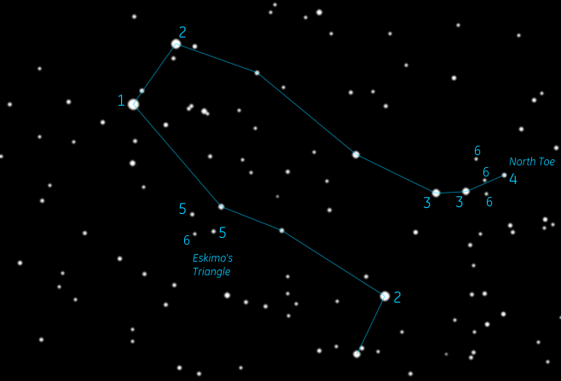

1. I called Gemini a Zodiac constellation. What is a "Zodiac" constellation? (I have been surprised to discover that few, if any, kids can answer this question.)

As the earth goes around the sun, this motion means that every day we look back at the sun in a slightly different direction, with different stars behind it. The sun appears to move through the constellations. Theoretically there are twelve constellations through which the sun moves, one per month, and these are the Zodiac constellations. In reality there is a 13th constellation through which the sun passes (technically, at least) and it gets no credit for being in the Zodiac - Ophiuchus.

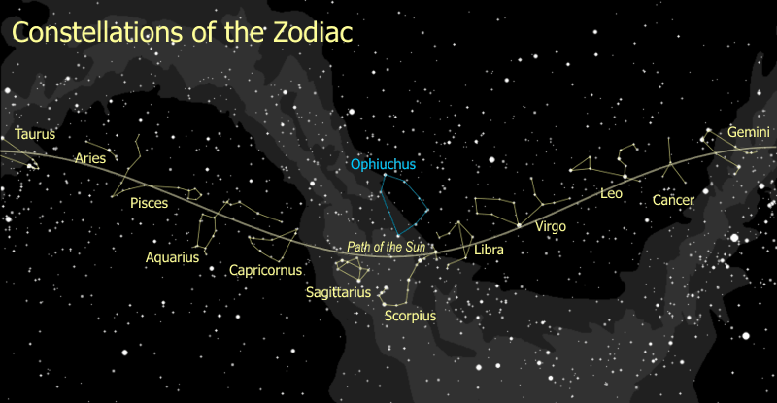

1. So Gemini is one Zodiac constellation, and we've already talked about another constellation on the path of the sun, can you guess which one? That's right, Taurus is another Zodiac Constellation, on the sun's path just to the west of Gemini, so the sun passes through Taurus, then Gemini, then it continues on through the next month's constellation, the ever so faint Crab with the unfortunate name of "Cancer". {Trace out Cancer the Crab} My real target here is the Beehive, and in some cases I don't bother with Cancer at all -- I simply tell the group to look halfway between the bright stars of Leo and the bright stars of Gemini -- in the center of the dark region is a faint fuzzy spot. Most people will see it right away.
2. It's so unremarkable I wouldn't even bother showing you this constellation, except for one thing... the Beehive. If you look very carefully at the center of the crab, you will see a hazy patch. Now look at that hazy patch through the binoculars. Wow, eh? That's the Beehive Cluster, about 500 light years away. It is about the same distance as the Pleiades (not nearly as bright, is it?) and the same age as the Hyades, 400 million years old, and some people think the Beehive & Hyades are related because they're both moving at the same speed in the same direction. The fact that they are about 450 light years apart is hard to explain though.

|  |
| --- |
| The Beehive is so big you can see it just by looking |
| C:\Users\randy\MyWebSite\astronomy\img\Beehive.gif |
|  |

1. If you're going for the Astronomy merit badge you need four Zodiac constellations and it just so happens you're in luck... we've got one more, this time going west from Taurus. So this is on the sun's path before it reaches Taurus; just to the west of the Pleiades you find the constellation Aries the Ram. The easiest part of the constellation to spot is a set of three bright stars forming a bent line or a very flat triangle. {Point out the central stars in Aries.} Most star charts only show these three stars. However, if you follow the line of the whole constellation you get a much better sense of the ram's horns. {Trace out the full constellation.}

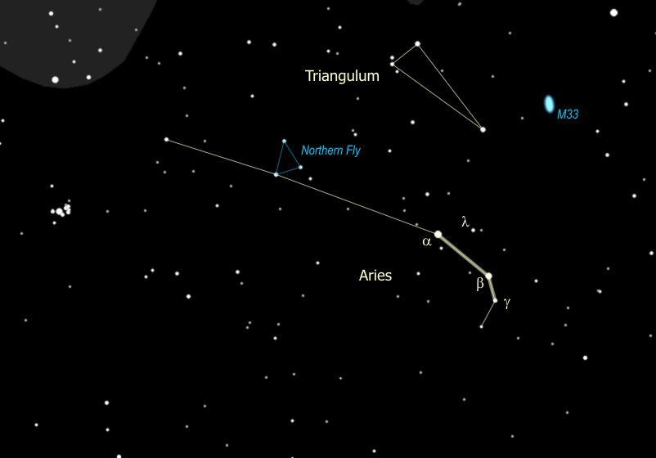

1. The little bitty triangle buzzing around to the left of the bright central stars of Aries used to be a constellation of its own, called the Northern Fly. {Point out the Northern Fly.} Mercifully the fly was gassed and now those stars are officially part of Aries. (There is a Southern Fly - since the demise of Northern Fly the Southern Fly is just the Fly - near the Southern Cross close to the South Pole. We can't see it.)
2. Just to the north of Aries you might notice a distinct, narrow triangle of stars, which happens to be another constellation whose name is, surprisingly enough, Triangulum. {Trace out Triangulum}
3. Aside from being a neat looking constellation, Triangulum is the home of another galaxy, M33. This galaxy is just a little farther from us than the Andromeda galaxy, about 2.4 million light years away, and belongs to our group of galaxies - astronomers refer to this as the "Local Group".

M33 has a reputation for being tough to see and we need a clear, dark sky to really be able to see it. {Point out M33's location} It is so big, faint, and spread out, that it is actually easier to see in binoculars (if we can see it at all) than in a telescope. On a very dark night you might even be able to see it with your eyes alone, by looking just to one side of it (averted vision).

1. The three bright stars of Aries are α (alpha), β (beta), and γ (gamma). If we get the telescope on γ, you can see that it is also a binary, a close pair of clear white stars. If you don't want to bother with the telescope you can spot another double with the binoculars -- mid-way and slightly above the line between α and β is λl Arietis, a bright yellow star with a faint yellow companion, just above it. You can spot the faint twin with 10x50 binoculars - if you hold them rock steady. Both of these double stars, γ and λ, are true binary systems -- twin stars that were formed together and are now orbiting one another.

# Canis Major

We saw the Little Dog Star, Procyon, in the Little Dog constellation, next to Gemini, so where is the Big Dog?

1. Remember the brightest star in the sky? It's Sirius, right there to the south. It's called the Dog Star because it is actually the nose of the Big Dog, Canis Major. {Trace out Canis Major, showing two eyes, the nose, front legs, back legs & tail}. Some people see Sirius as the dog's collar, I prefer seeing the eyes & nose myself.

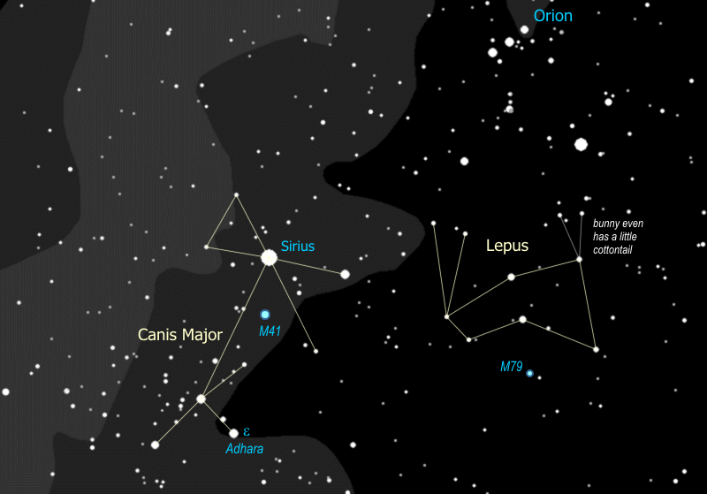

1. Of the stars you can see by eye, Sirius is the second closest, only about 9 light years away. Anyone know the closest? Yes, Alpha Centauri, which is 4 light years away, and can only be seen in the Southern hemisphere. Sirius is actually a double star. It has a white dwarf companion, a star that has blown off its outer envelope of gases and collapsed into a burning core that is about the mass of the sun packed into space about twice the diameter of the earth. A white dwarf is what our sun will eventually become. The companion can only be seen in the biggest telescopes, we can't see it with our little bitty one.
2. So part of the reason Sirius is so bright is because it is so close. It is also about 20 times as bright as our sun, that obviously helps too. The star at the dog's back foot is ε (epsilon) Canis Majoris, also known as Adhara. This is the second brightest star in the Big Dog, and is also four HUNDRED light years away. In reality it is 170 times as bright as Sirius and almost 4,000 times as bright as our sun. If Adhara were as close as Sirius you would be able to see it in the daytime and it would cast a shadow at night... 16 times as bright as Venus (at its brightest)!
3. If you look with the binoculars right about where the dog's heart would be you can see a gorgeous star cluster, M41. In fact if we have a clear, dark sky you can see M41 with your eye alone, as a hazy spot. This is an exceptionally bright cluster when you realize that it is nearly 2400 light years away... six times as far as the Pleiades!

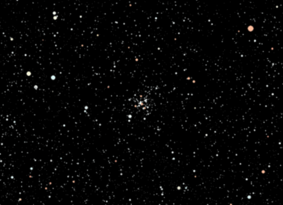

1. Right next to Canis Major, the hunting dog, at the feet of Orion, the great hunter, is Lepus the Hare. How's that for being in the wrong place at the wrong time? This is one constellation that really looks like what it is supposed to be. {Trace out Lepus, showing the ears, nose, & little cottontail.}
2. Check out the star at the bunny's chin -- even in binoculars you can see that it's really a double star, the brighter one is pale yellow, similar to our sun, and the fainter one above it is a small, orange star.
3. There is one peculiar object of interest in Lepus, the globular cluster M79. It is probably too difficult to see even in the telescope but if conditions are especially clear and dark I will give it a shot.

What's so interesting about this globular cluster is that it's in the wrong part of the sky. All the clusters we've looked at are open clusters. Globular clusters are very different, and this globular cluster is all alone on this side of the sky. The summer sky is just filled with globular clusters -- for some reason all the globular clusters are close to the center of the [Milky Way galaxy](file:///C:\Users\randy\MyWebSite\astronomy\Winter\Auriga.html#MilkyWay), and in the summer we are looking toward the center of the galaxy. Now we are looking out toward the edge of the galactic disk, and there's this one lone globular cluster -- why would that be?

Well, in November of 2003, it was discovered that the Milky Way is eating up a smaller galaxy -- it is called the Canis Major galaxy because most of what's left of it is in the direction of the Big Dog. It was caught in the gravity of the Milky Way and now is being pulled apart and is getting sucked into the disk of our galaxy. M79 is a globular cluster that was a part of that little galaxy, not originally part of our galaxy, which is why it's in the wrong place.

If you follow the line of the two stars at the center of the rabbit's body south to the next star, M79 is right next to that star. Instead of being a randomly scattered group of stars, a globular cluster is a well-defined ball, glittering with hundreds of thousands of stars. Globular clusters are rare - only about 150 are known, and they are completely different from open clusters like the Pleiades or M35 in Gemini.

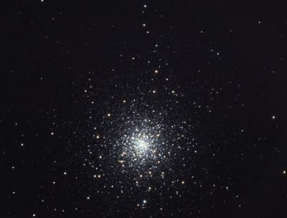

The Pleiades are about 100 million years old, M79 is estimated to be at least 10 BILLION years old, making it so old that it formed before the disk of the Milky Way galaxy formed! While the Pleiades cluster has maybe 500 stars in total, M79 has several hundred *thousand* stars, maybe a million. The Pleiades are about 400 light years away and about seven light years across, while M79 is 40 *thousand* light years away and 100 light years across.

These numbers are typical -- globular clusters are much, much bigger than open clusters, and they are much much older - some are nearly as old as the universe!

So we've come full circle. We started with Orion the Hunter and here we are, back with Orion. Our winter sky tour is completed. For the die-hard stalwarts with a particularly high resistance to the night chill, we may continue on to observe some additional deep sky objects, perhaps some of the ones we skipped for the sake of time. Or we might learn a few additional constellations, like Leo which is on the rise about this time. But that's really part of the Spring Sky Tour, and we don't want to start getting ahead of ourselves, particularly since we've covered so much already.

# Tell Time by the Big Dipper



Using the Big Dipper to tell time (by the line from the pointer stars to Polaris) is easy.

* It's a backwards (counter-clockwise) running 24-hour clock, because the earth turns west to east a full turn every 24 hours, and
* It runs fast. Due to the earth's yearly orbit around the sun, it gains 24 hours each year.

So to use the clock you only need to do two things.

* Remember the 24-hour clock face, shown above, and
* Adjust the 24-hour (midnight) mark on the clock to the current date. 24 hours in 12 months is two hours every month, so shift the midnight mark up by two hours (counter-clockwise) on the clock each month, or a half-hour each week. Some key dates to remember are shown on the drawing.