|  |  |  |
| --- | --- | --- |
| C:\Users\randy\MyWebSite\astronomy\img\FallSkyTour.gif | Autumn Sky TourRandy Culp | C:\Users\randy\MyWebSite\astronomy\fall.gif |

The autumn sky brings some of the faintest constellations carrying the brightest legend - the story of Andromeda and Perseus. With this sky you have the opportunity to tell the story in full, illustrated in spectacular fashion by the stars. While there are many other bright constellations up at this time with interesting features of their own, the Andromeda Legend is the centerpiece of the sky and the backbone of the Autumn Stargazing Tour.

The account here is the agenda that I loosely follow in providing a guided tour of the autumn skies as visible from 45° North Latitude. This tour is designed for one topic to lead to the next, so it flows nicely and still manages to teach Astronomy under the night sky as we caravan from one constellation to another. Aside from the binoculars and telescopes I usually make a point of also bringing a highly focused flashlight which serves as an effective pointer for tracing out constellations.

Note that this tour is specifically designed to meet requirements 5, 7 and 8 (b) of the Astronomy merit badge, although of course there are lots of other tidbits here that go beyond the requirements of the badge.

Updated 14 April 2021

***View to the South***   
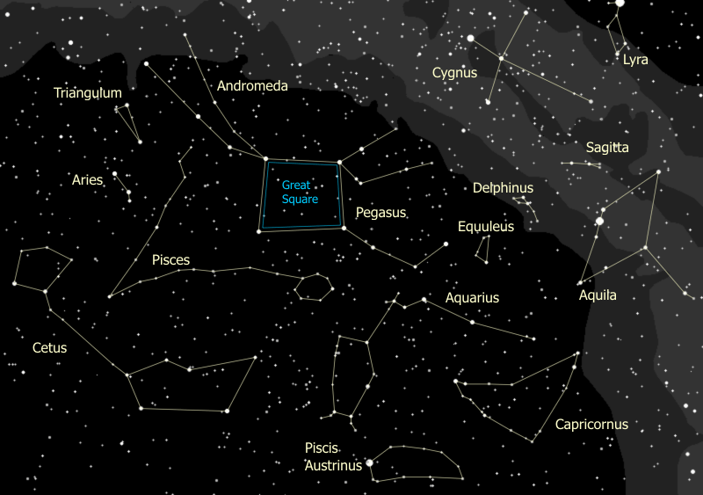

***View to the North***   
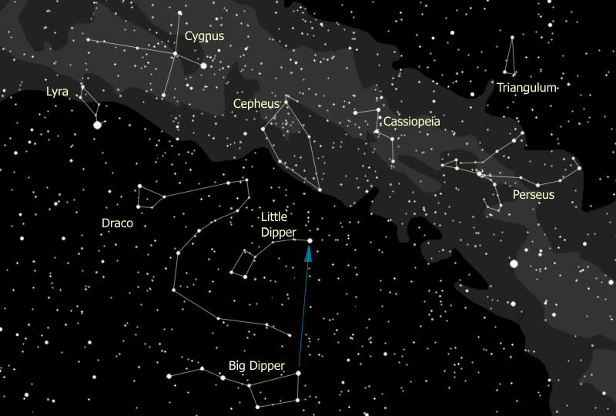

## Index to the Tour

C:\Users\randy\MyWebSite\astronomy\img\star.gif[Polar Constellations](#_The_Polar_Constellations)   
C:\Users\randy\MyWebSite\astronomy\img\star.gif[Down the Milky Way](#_Down_the_Milky)   
C:\Users\randy\MyWebSite\astronomy\img\star.gif[The Zodiac Constellations](#_The_Zodiac_Constellations)  
C:\Users\randy\MyWebSite\astronomy\img\star.gif[The Andromeda Legend](#_The_Andromeda_Legend)  
C:\Users\randy\MyWebSite\astronomy\img\star.gif[Perseus the Hero](#_Perseus_the_Hero)

## Overview of the Tour

I actually start the autumn tour with a quick observation of the Great Square, since you can scarcely move around the sky without stumbling across it. We then turn to the polar constellations, wind our way down the Milky Way, skirt across the southern horizon following the Zodiac, then finish with the Andromeda Legend as the grand finale. Under a time pressure, I have been known to tell the story of Andromeda, then pick up other items of interest as time permits.

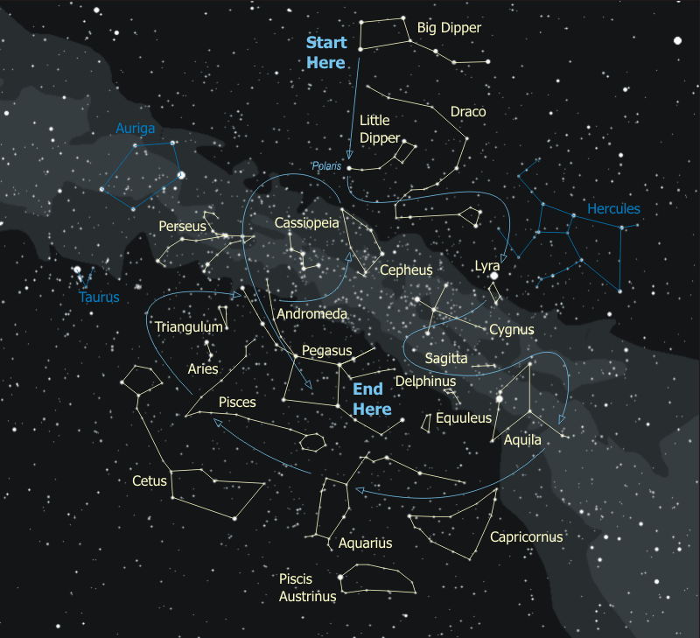

## The Top Attractions

Time might be limited, if it's chilly, if conditions are changing, or else if time is just limited. In that case, these are the best items to hit - the ones that the kids (and the adults) are talking about days later.

|  |  |  |  |
| --- | --- | --- | --- |
| **Feature** | **Naked Eye** | **Binoculars** | **Telescope** |
| Mizar & Alcor | ✓ | ✓ |  |
| The Double Double |  | ✓ | ✓ |
| The Ring Nebula |  |  | ✓ |
| The Coathanger |  | ✓ |  |
| Albireo |  | ✓ | ✓ |
| Andromeda Galaxy | ✓ | ✓ | ✓ |
| d Cephei | ✓ | ✓ |  |
| Algol the Demon Star | ✓ | ✓ |  |
| Double Cluster |  | ✓ | ✓ |
| M15 (Globular Cluster) |  | ✓ | ✓ |

# The Polar Constellations

The autumn sky is dominated by the Great Square of Pegasus, four stars that form a huge square in the sky, which you can see if you look almost straight up. See it? The stars are a bit faint, but it's distinctive because it's in a faint portion of the sky. The earth has swung around the sun to the southern face of our galaxy so we are now looking out of the disk of the galaxy towards its south pole. As a result, the region of the Great Square has few nearby bright stars. If you follow a straight line through the two stars on the right side of the square up over the top of the sky and back down, it takes you to the North Star.

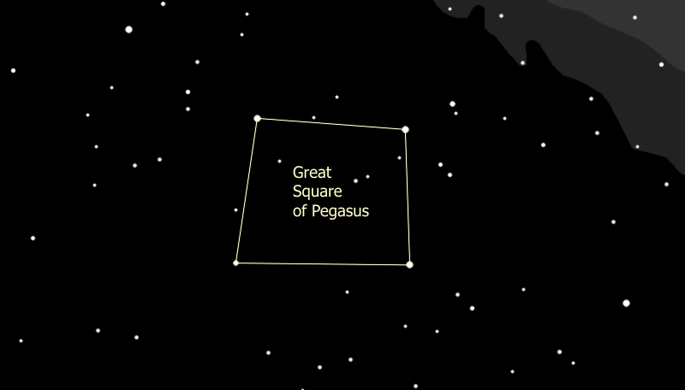

1. We start our tour by turning our attention to the North. Anybody recognize anything? If you're looking for the Big Dipper, it's there, scraping along the northern horizon. You may only be able to see parts of it over the tops of the trees. {Trace out the Big Dipper}.

It's really not a constellation, it's what's called an 'asterism', a highly recognizable part of a constellation. The full constellation is Ursa Major, and is hopelessly lost beneath the horizon at this time of the year.

1. The Big Dipper is a polar 'constellation' -- one that is very close to the North Pole. If stars are close enough to the pole they never set below the horizon and we can see them all year long. Can anyone spot the Pole Star? How do you find it? That's right, the two stars at the front edge of the cup are pointer stars and point to the North Star, whose actual name is Polaris. Go up from the cup to find Polaris.

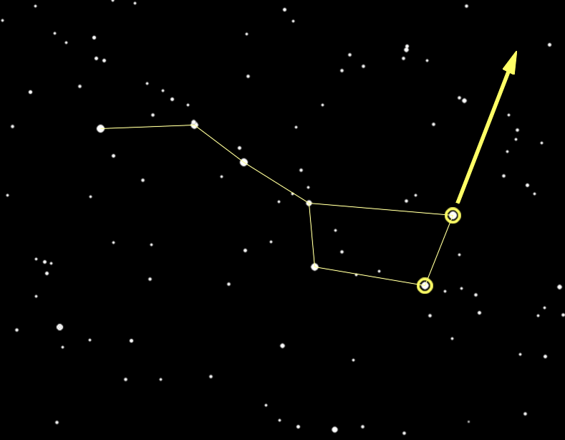

1. Since the earth's north pole points to Polaris and the earth rotates around its poles, all the constellations seem to rotate around Polaris, including the Big Dipper. You can tell time using the Big Dipper -- it serves as a 24-hour clock.

Click on the little clock [here [C:\Users\randy\MyWebSite\astronomy\img\tt32.gif](#_Tell_Time_by)](#_Tell_Time_by)for more information.

1. Polaris is a part of the constellation Ursa Minor, more commonly known as the Little Dipper. Polaris is at the tip of the handle. {Trace out the Little Dipper.}

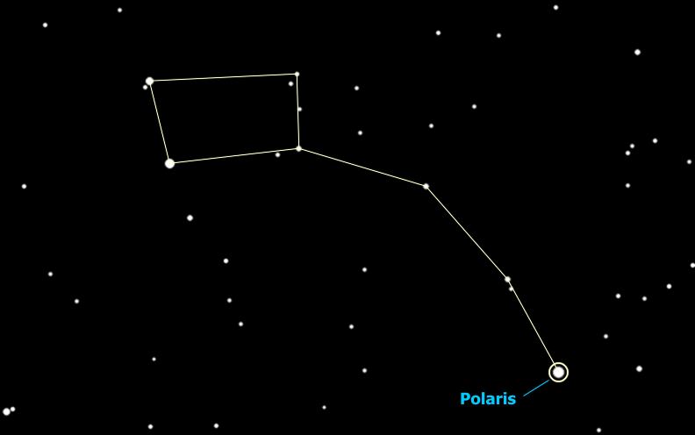

1. Threading his way between the Big Dipper and the Little Dipper is Draco the Dragon. {Trace out Draco.} Draco starts off with two bright yellow eyes (actually one's yellow, one's orange), and then winds around the little dipper with its tail between the two dippers. This is a very cool-looking constellation, a rare one that looks like the monster it is supposed to be, glaring yellow eyes and all. The head of Draco forms a distinct asterism, known as "The Lozenge". Who's got the binoculars? Use them to find Draco's eyes, then go down to find the next star in the Lozenge closest to the eyes -- n (nu) Draconis. Notice anything? That's right, it's a double star, and a very neat one in binoculars, tight together and exactly equal in brightness.

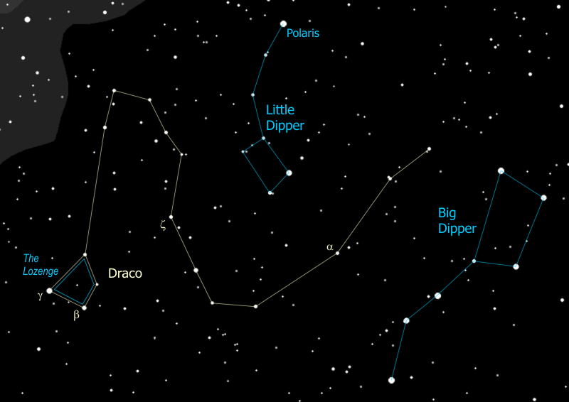

1. The two most important Polar Constellations to recognize are the Big Dipper and the Big W, and the Big Dipper is so low this time of year that it is now even more important to recognize the Big W. The Big W is Cassiopeia - roughly on the opposite side of Polaris from the Big Dipper {Trace out Cassiopeia}. Well, it's upside down now so it looks more like a big "M". Cassiopeia is a Queen in her chair, and even though this isn't the "official" way to look at her, I envision Cassiopeia's head at the left side of the "W", making the figure like a lounge chair with a foot rest. This is how I learned it as a kid, and it's very useful because you can easily find the North Star by going "Up from the Seat" of Cassiopeia's chair, in similar manner to going "Up from the Cup" of the Big Dipper. Since the Big W is on the opposite side of the North Star, this gives you a way to find Polaris any time of the year, even now when the Dipper likes to hide below the tree line.

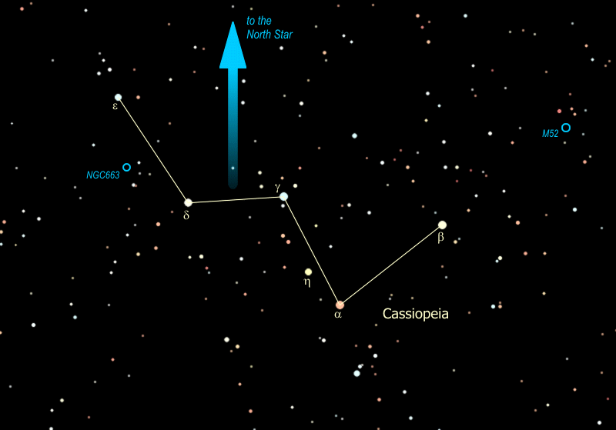

1. Cassiopeia got herself into a lot of trouble, leading to the story of Andromeda and Perseus and involving no less than six constellations in the sky, the most involved in any of the constellation legends. You'll hear more about that story in a moment.
2. The constellation Cassiopeia lies right smack in the middle of the [Milky Way](file:///C:\Users\randy\MyWebSite\astronomy\Fall\MilkyWay.html), and is filled with galactic clusters, also called open clusters. These are small groups of stars, maybe a hundred or so, that formed from the same (huge) cloud of gas and dust. They are very often young stars - blue ones which are large and very hot and don't last long.

There are several decent examples in Cassiopeia, like Messier object #52, or "M52", one of many "M" objects named after a catalog published in the late 1700's by the Frenchman Charles Messier. Messier was a comet hunter of great renown who published a catalog of fuzzy things that might be confused with comets. These ended up being some of the most interesting objects in the sky. When you find M52 you are looking at a "young"cluster of about 200 stars -- young means that it is only about 100 million years old. The cluster is 10 light years in diameter and 3000 light years away from us, which is why you need the binoculars to see it.

Another interesting galactic cluster is NGC 663 (NGC stands for New General Catalog -- published in 1888 it's not really that new). This cluster lies about half way between the two stars on the flattened side of the "W", e and d Cassiopeiae. As you sweep the binoculars between the two stars, you will notice that NGC 663 is merely the largest and brightest of several clusters in this region. That may be because it is the closest, at about 3000 light years. The others in that area are 6000 - 8000 light years away. How many clusters can you spot between these two stars? You might be able to see as many as five, with NGC 663 at the center and the other four marking the corners of a diamond around it.

|  |  |
| --- | --- |
| M52 - Note the little box of stars around the cluster | NGC 663 - halfway down the left side of the "W" |
| C:\Users\randy\MyWebSite\astronomy\img\M52.jpg | C:\Users\randy\MyWebSite\astronomy\img\NGC663.jpg |

1. While you're scoping around for clusters with the binoculars, you notice anything unusual about the brightest stars of Cassiopeia? They're not all just points of white light, are they? Some are bright yellow, some are orange, almost red, and some are blue! There, the one at the center peak of the W (g Cassiopeiae), that one's blue, then if you go to the bright one down and to the right ( a Cassiopeiae), that one's orange, and the brightest star you see between those two (h Cassiopeiae), that one's yellow. So what do the star colors mean? Why would one star be blue and another red?

Yup, that's right. Different colors show different temperatures. So which star color is the hottest? Just like a flame, blue is the hottest part, yellow is next, red is the coolest. The sun is a yellow star, about 10,000°F at the surface. A red star is about half the sun's surface temperature, whereas a blue star is three to five times as hot as the sun. White stars are somewhere between the yellow ones and blue ones.

Now, all stars are made of pretty much the same stuff -- about 90% hydrogen and the rest is helium with some traces of other stuff. So, why would one star be burning hotter than another? The answer is in the size of the star. The more massive it is, the more pressure there is at the center and therefore the hotter - and for that matter the brighter - the star burns. So blue stars are the biggest and brightest of stars, and red stars are the smallest and dimmest.

So why is red a Cassiopeiae so bright? Hmmm... yeah... well, like with most rules, there are exceptions to the rule, and this rule is no exception. a Cassiopeiae is a star that is literally running out of gas. As a star burns up all the hydrogen at its center, it starts to burn helium (which is the "ash" from the hydrogen burning), which makes it expand, get brighter, and turn red -- it becomes a red giant. This is the time you can get a bright red star, when the star is near the end of its life.

When our sun starts burning out it will expand so big it will swallow up Mercury and Venus and scorch the surface of the earth to a cinder. If you are hoping to see all that happen you will have to wait about 5 billion years.

So there are two reasons a star could be red -- it is massive (and once was yellow, white or even blue) and is now burning out (a red giant), or it never had enough mass to burn any hotter than red (a red dwarf).

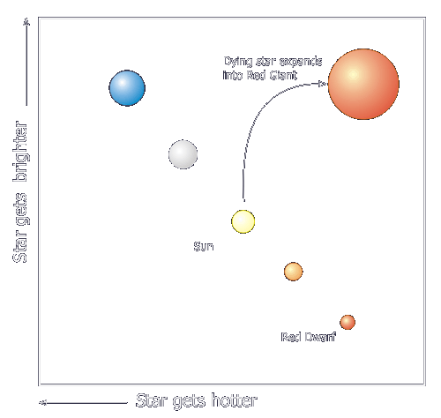

Notice that when we graph out the stars showing their temperature (or color) against their brightness, most of them fall along a line -- this line is called the Main Sequence, and the graph is called the "H-R" (for Hertzsprung-Russell) Diagram. Others are not on the main sequence, mostly stars that are either just being born (called "T-Tauri" stars) or stars that are near the end of life.

1. So the Big Dipper points out the North Star, and the three stars of the handle are pointers as well, but the stars they point to, while important, are below the horizon right now. Wait a minute is that really three stars in the Dipper's handle or is it four? Looky there the middle star seems to have a companion -- the bright star is Mizar and the companion is Alcor. Who can see the companion?

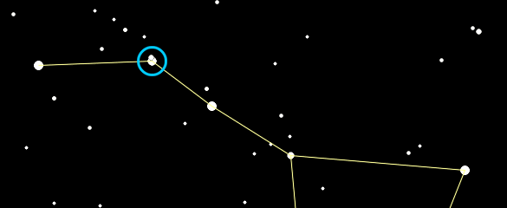

That was used by ancient Greek and Arab armies as an eye test. Some see them as a horse & rider. The Europeans saw the handle of the dipper as the tail of the Great Bear. Since bears don't have tails they danced around it by explaining that when the gods lifted the bear to the sky the tail got stretched out. Pretty lame. The Indians, who knew darn right well that bears don't have tails, saw the three stars of the handle as hunters chasing the great bear (interesting that they also saw a bear). When the constellation Ursa Major sets in the fall, the Indians explained that the hunters catch up with him and shoot him with their arrows, which is why the leaves on the trees turn red. Anyway the three stars are hunters and one of them brought his dog, so Mizar is a hunter and Alcor is his dog. Or another story is that there are three hunters pursuing the bear and one brought a pot to cook the bear in (optimistic). So Mizar is a hunter and Alcor is his pot. Yet another story involves the Pleiades. This is a star cluster in the constellation Taurus (a winter constellation -- we may see them a little later tonight). It is called "the Seven Sisters" and those with very sharp eyes can see seven stars but most people can only see six. So the story is that Mizar is riding off with the Seventh Sister.

# Down the Milky Way

1. You can see the Milky Way on any clear fall night, but under a dark sky, on especially clear nights, the Milky Way glows like a neon light, from north horizon to south horizon, and seems bright enough to light your path. Most people recognize the Milky Way as a band of light across the night sky, but what is that band of light - where does it come from?

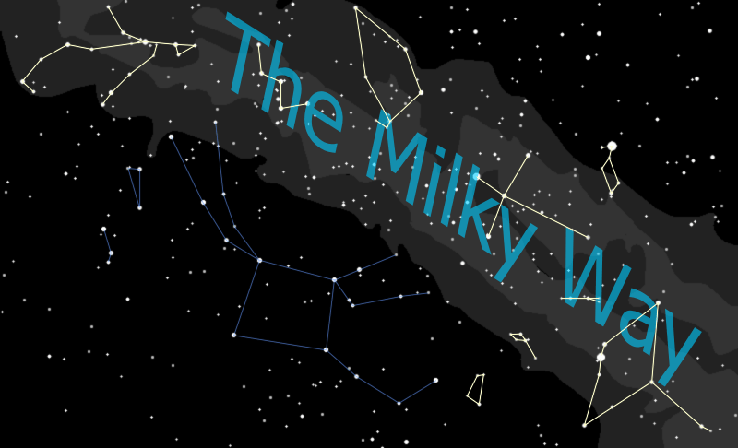

1. Well it's a bit like looking at a gravel road. Close to you, you can see individual stones, while off in the distance the road merges into a uniform gray. When you look at the Milky Way you are looking at the disk of our galaxy from the inside - the nearby stars you can see individually (most are less than 1,000 light years away), the distant stars merge into a hazy glow. So when you see that band across the sky you are really looking way off into the distance, into the "billions and billions" of stars that make up the disk of our galaxy.

You'll see a similar phenomenon later when you look at the Wild Duck Cluster in Aquila. Through binoculars you will see it as a hazy patch. When you see it through a telescope - that is, closer up - you can pick out individual stars. The better the telescope, the 'closer' you can get to the cluster, the more stars you can see.

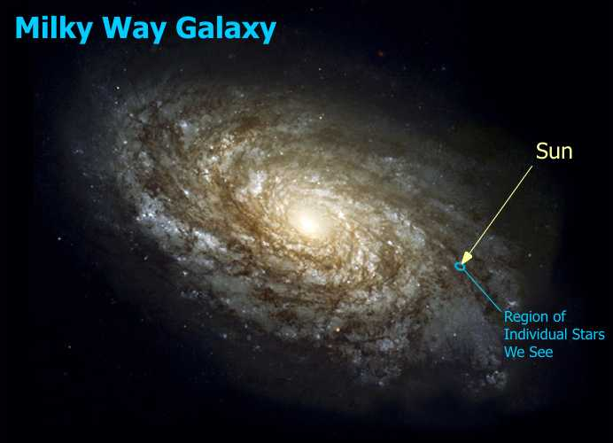

1. Now as you look up at the Milky Way you can't help but notice a really bright star just off the Northwest edge of the band. That star is the renowned **Vega**, the home of the aliens in the movie Contact. Vega is a zero magnitude star, about 25 light years away, 3 times the mass of the sun, and about 50 times as bright as the sun. Imagine having 50 suns in our sky. If Vega was our sun we'd be cooked.
2. Vega is part of the constellation Lyra the Lyre. {Trace out Lyra.} It is easily recognizable as a parallelogram of four stars right next to the very bright Vega. This constellation represents a lyre, or harp, with Vega at the top of the lyre as one of the handles. (The other handle must have broken off.)

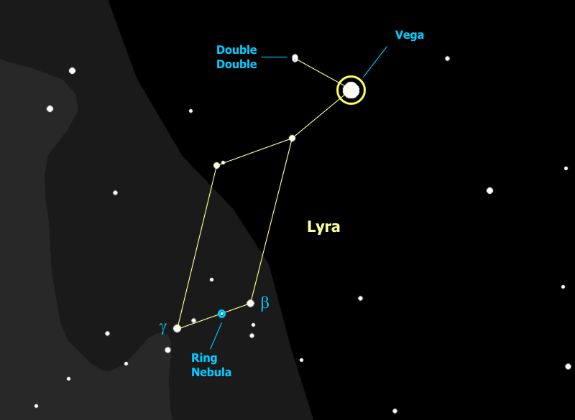

1. The star next to Vega to the northeast (or up and to the left), e (epsilon) Lyrae, is actually a double star when you look at it in binoculars. However, if we can get a good telescope on that star you will see that each of the stars in the double is itself a double - a very cool sight to see. These four stars form a set that is a true double-double star, formed from the same nebula, which was spinning so fast it first spun apart into two protostars. They in turn each spun themselves apart into two stars.
2. The parallelogram star to the southwest, the lower right-hand corner of the lyre, is b (beta) Lyrae, which is variable star - it is usually about as bright as the southeast, or lower left-hand corner star g (gamma) Lyrae. Every 6½ days the star dims to half its brightness. Any ideas why this might happen? This star is an "eclipsing binary" - two stars orbiting each other every 13 days. Every half orbit one of the stars passes in front of the other and instead of seeing two stars we only see one - the star drops to half its brightness, which is about a magnitude. So take a look at b Lyrae - do you think it's eclipsing right now?
3. Now if we can get a telescope aimed right about half way between g and b Lyrae (a little closer to b) and look in the eyepiece, you'll notice something a little funny - it doesn't look like a star at all, it looks more like a - smoke ring maybe. This is the famous Ring Nebula - what is called a "planetary nebula", formed when a star blows off its outer envelope of gases. The radiation from the exposed, white-hot core of the star lights up the expanding shell of gases just like a neon light.

I have heard it said that a planetary nebulae is the wreath that Mother Nature places around dying stars.

|  |  |
| --- | --- |
| Ring Nebula in Telescope | Hubble Telescope Image of Ring Nebula |
| C:\Users\randy\MyWebSite\astronomy\img\RingNebulaInEyepiece.jpg | C:\Users\randy\MyWebSite\astronomy\img\RingNebulaAnnotated.jpg |

1. We can find some more constellations -- some of the best -- by following the Milky Way down from Lyra to the horizon. Right next to Lyra is Cygnus the Swan. {Trace out Cygnus}. This constellation is also known as the Northern Cross and at Christmas time, in the evening, it has rotated across the sky so it is standing on its base on the northwestern horizon, with the bright star Vega next to it. Very Christmas-y.

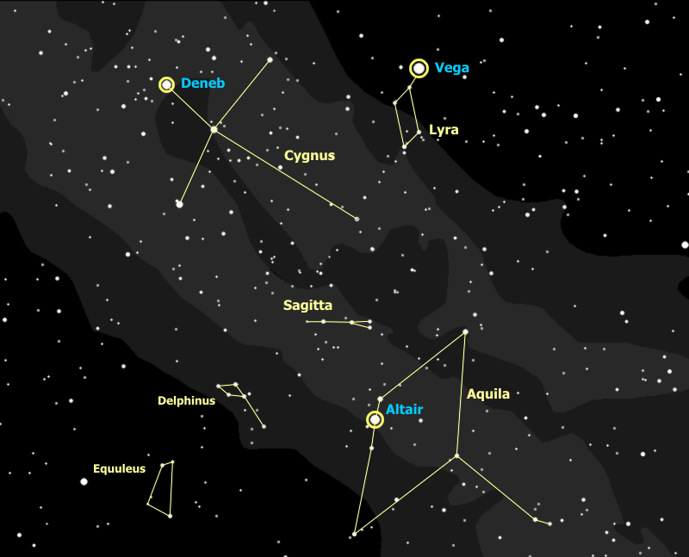

1. Deneb is the star at the tail of the Swan. Notice that it's about as bright as Vega, which is 25 light years away -- so about how far would you guess Deneb is? As it happens... Deneb is **2500** light years away - 100 times farther!! Deneb is actually 4,000 times brighter than Vega and 200,000 times brighter than our sun. If Deneb were as close as Vega, it would be visible in broad daylight and would cast a shadow at night. This star is one of the greatest super-giant stars known.
2. So what do you think, is Deneb the brightest star in the sky right now? Do you see any stars you think might be even brighter? Yes, of course, Vega is considerably brighter than Deneb, mainly because it's closer. How about Polaris? Which would you say is brighter, Deneb or Polaris?

Astronomers measure star brightness using 'magnitudes' -- Vega has a magnitude of 0, Deneb has a magnitude of 1, and Polaris has a magnitude of 2. As magnitude number goes up, brightness goes down. A magnitude 1 is 2½ times as bright as a magnitude 2, a 2 is 2½ times as bright as a 3, and so on.

This comes from the system set up by ancient Greeks, where the brightest stars were stars of the first magnitude, like 'first class', and the faintest stars you could see were stars of the sixth magnitude. When astronomers got telescopes and instruments that could measure star brightness, they found 1st magnitude stars were almost exactly 100 times the brightness of 6th magnitude stars. That works out to a factor of 2½ from one magnitude to the next.

Magnitudes can go negative for stars brighter than 0 magnitude Vega. Sirius, a winter star in the constellation Canis Major (the Big Dog), is the brightest star anywhere in the sky with a magnitude -1.5.

Well, what's really the brightest star in the sky? The sun has a magnitude of -27.

1. Now even though it is a massive super-giant, Deneb is actually a very young star, at least compared to the sun. Deneb was born only about 3 million years ago, long after the Dinosaurs died out, and is already approaching the end of its life -- the star can last at most another million years. Compare this to the life of our sun -- it has been around for 5 *BILLION* years, and has another 5 billion left in it. This is because Deneb is so much more massive than the sun. The greater mass causes greater pressure and forces the star to burn much hotter (bluer) and faster. With stars, the bigger they are, the harder they fall.
2. Albireo, the star at the head of the swan, is actually a beautiful double star, a yellow giant and a blue main-sequence star. You can just split this star with good binoculars held steady, and it looks better in a telescope.
3. The next constellation we reach is Aquila the Eagle. {Trace out Aquila.} The bright star is Altair, and the two stars on either side of Altair are called the Pilot Stars. Altair is 16 light years away. It's about half again as big as our sun and nine times as bright. That shows how sensitive stars are to mass -- just a little more mass causes the star to burn much brighter.

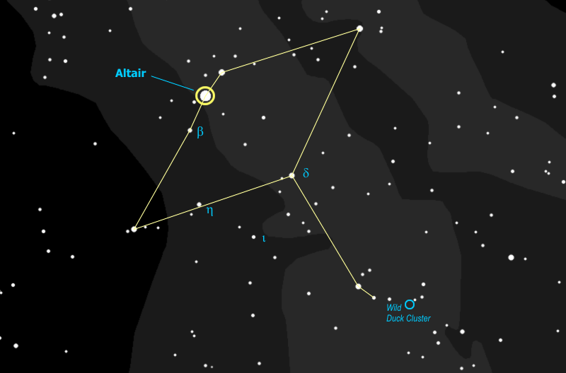

The star that is about halfway between Aquila's eastern wingtip and his body is called h (Eta) Aquilae -- and this is a [Cepheid variable](file:///C:\Users\randy\MyWebSite\astronomy\Fall\Andromeda.html#Cepheid) -- the star itself is unstable and pulsing -- with a cycle of about 7 days. At it's brightest it's nearly as bright as the body star, d (Delta) Aquilae (actually it's as bright as the eastern Pilot Star b Aquilae), and at it's dimmest it's about as bright as i (Iota) Aquilae. This is one of only three Cepheids you can see by eye - you will meet d Cephei, the original, very shortly and the third one is in the winter constellation of Gemini.

1. If you look with the binoculars you can find the two stars of Aquila's tail, then slide west (to the right) until they are at the far left of the field of view. To the far right of your field of view you can now see a fuzzy spot with a star at the center - you have found the Wild Duck Cluster. In a telescope this looks like a dense cluster of tiny stars broken into groups - the central group is V-shaped and looked to early observers like a flight of wild ducks - hence the name.
2. So you have now been introduced to all three stars of the Summer Triangle: Vega, Altair, and Deneb. See the triangle? Learning to recognize this can be a good way to orient yourself in the sky, especially early in the evening when the stars are first coming out.
3. Just above and to the east of Aquila you can spot a small diamond of stars with a little tail coming down. This is the tiny constellation, Delphinus the Dolphin. It really looks like a little dolphin, doesn't it?
4. Then next to Delphinus, continuing to the left (east) is another teeny tiny, and faint constellation, Equuleus the Horse. It's four stars forming a horse's head, with the nose pointing up, to the North. See it? Actually it's five stars, the corner by his jaw is a pair of stars. Equuleus is nearly the smallest constellation in the sky -- only the Southern Cross, next to the South Pole, is smaller.
5. The two birds, Aquila the Eagle and Cygnus the Swan, are flying straight at each other and, to enhance the suspense, Sagitta the Arrow flies between them, just missing both. {Trace out Sagitta.} What is most interesting about Sagitta, though, is not so much the constellation as the features for which it is a milestone. (Note: these two features, technically, are in the neighboring and very faint constellation "Vulpecula" the Fox.)

If you locate the two tail-feather stars of Sagitta in binoculars then follow the line between them up (to the northwest), just one field of view, you will see the Coathanger, an interesting cluster of stars.

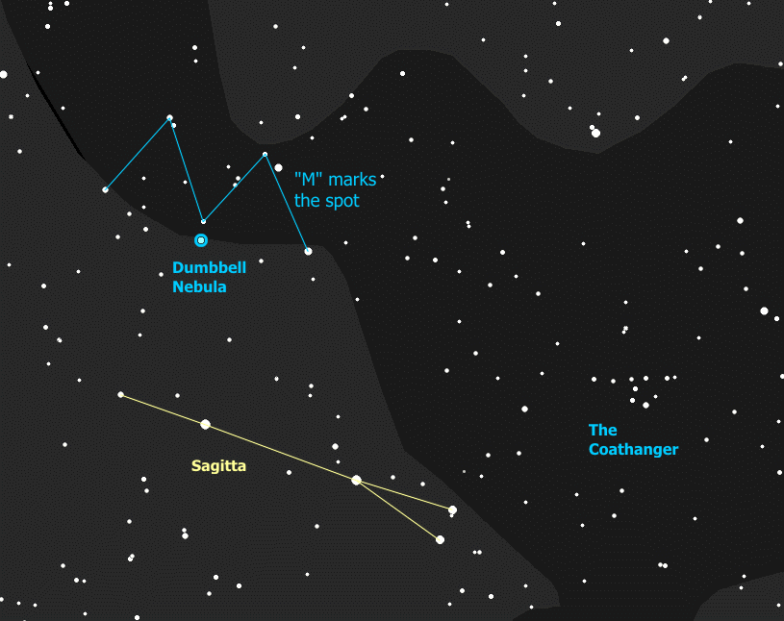

If you are really good with those binoculars you can go up from the tip of the arrow, toward Albireo in Cygnus, and you will find a group of stars that just fill the field of view in the shape of an "M". Right at the central point of the "M" is a faint fuzzy patch that actually is known as the "Dumbbell Nebula". To really see it requires a telescope. This is another planetary nebula - a shell of gas blown off by a dying star, and lit up by the radiation from the exposed core of the star, now a "white dwarf".

# The Zodiac Constellations

1. Well, we've hit the horizon and run out of Milky Way so we'll hang a left and head south along the horizon, which brings us to the Zodiac constellation Capricornus. This is a faint constellation, you have to look hard to see it. In rough terms it's an upside-down triangle, curved a little bit so it starts to resemble a big smile. {Trace out Capricornus} Unfortunately it isn't called Capricornus the Big Smile, it's called Capricornus the Goat. Well actually, a goat with a fish tail. See it?

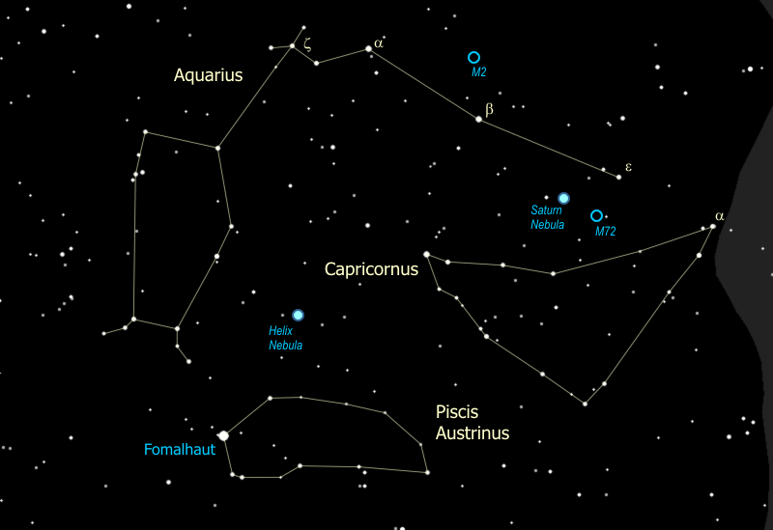

Nah, me neither. But here's what you can see, if you look hard at the brightest star of the (not too bright) constellation, at the upper right (Northwest) corner, α Capricorni, also called Giedi Prime. For you Dune fans, yes, that's where the bad guys live. But look at it... is that one star or two? What do you think? That's right, it's two -- hey hey hey, that's cheating, looking in the binoculars! They aren't related to each other, the dimmer one to the right is about five times farther away than the brighter one to the left, but it turns out each one is itself a true double. Ah - so no wonder it's the brightest star in Capricornus - it's four stars.

1. I called Capricornus a Zodiac constellation. What is a "Zodiac" constellation? (I have been surprised to discover that few, if any, kids can answer this question.)

As the earth goes around the sun, this motion means that every day we look back at the sun in a slightly different direction, with different stars behind it. The sun appears to move through the constellations. Theoretically there are twelve constellations through which the sun moves, one per month, and these are the Zodiac constellations. In reality there is a 13th constellation through which the sun passes (technically, at least) and it gets no credit for being in the Zodiac - Ophiuchus.

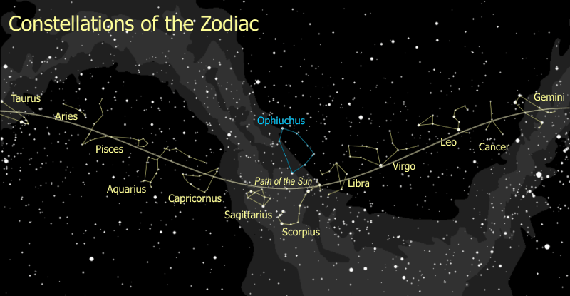

1. Now directly above Capricornus, and below the Great Square of Pegasus, we have the next of the Zodiac constellations, Aquarius. Yes, this is THE Aquarius, as in the Age of Aquarius in the song. Aquarius is just as faint as Capricornus, and it's an odd constellation that wanders around the sky. As a result, it's best to find it piece by piece.

Aquarius is a water carrier, pouring his pitcher of water into a standing urn. We start with the figure of Aquarius, which is a straight line, which begins just above Capricornus {I'm pointing to ε} and angles up and to the left {drawing a line to β then to α}. His water jar is the "Y" shaped figure of stars next to α Aquarii, and is probably the easiest part of the constellation to identify. The urn is then right below it {trace out the urn}, complete with little feet holding it up.

Remarkably, the third bright star down on the right side of the urn, δ Aquarii, is a member of the *Ursa Major Moving Group!* That's a pretty big "open cluster".

1. Just below Aquarius you can see a lone bright star in the sky, a first magnitude star by the name of Fomalhaut (pronounced like "foam a lot"). This is the eye of the Southern Fish, Piscis Austrinus. Just below Fomalhaut is a pair of stars forming the mouth of the fish, and the remaining stars trace out the body of the fish quite nicely {Trace out Piscis Austrinus} He even has a little fishy-fin. Fomalhaut is easily recognized since it is the one bright star to the south in the fall. It is also part of a constellation that looks just like what it is supposed to be.

1. Piscis Austrinus is not a Zodiac constellation, but the next Zodiac constellation is also a fish, in fact it's two fishes, known as Pisces. This is another really faint one, and we will start on it with a faint but distinctive asterism known as the Circlet, just below the Great Square of Pegasus, a little circle (or more accurately, an oval) of stars that represent one of the fishes. The rest is tricky, as it represents a cord that ties this fish to the second. The cord forms a "V" shape, with our Circlet at one tip of the V and the other fish, represented by just three stars, at the other tip. {Trace out Pisces}

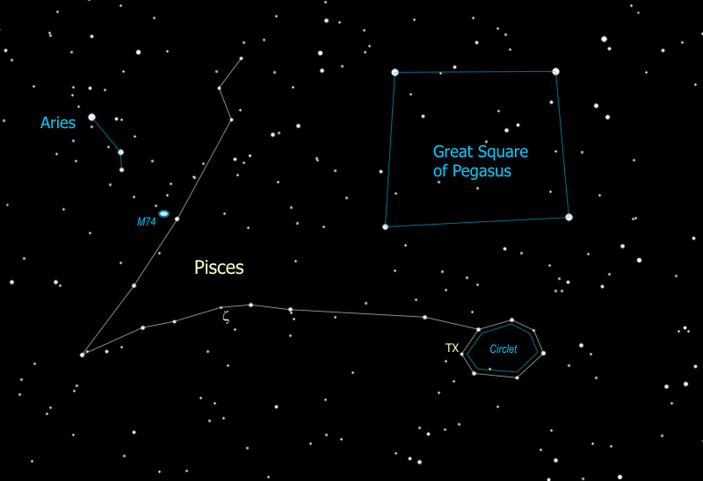

Two stars of note in Pisces are ζ (zeta) Piscium, and another star with the peculiar designation of "TX". To appreciate ζ we will get it in the telescope, where you can see it is a very nice binary star - a white star with a fainter yellow companion to the northeast. Meanwhile TX, the leftmost (eastern-most) star of the circlet, is just a red star -- a really, really red star. This star is a "carbon star" - it has been red giant a long time, burning the helium ash from the burned-up hydrogen and producing carbon. That means this is a very old, and very red, red giant star.

1. If you're going for the Astronomy merit badge you need four Zodiac constellations and it just so happens you're in luck... we've got one more, this time going west from Taurus. So this is on the sun's path before it reaches Taurus; just to the west of the Pleiades you find the constellation Aries the Ram. The easiest part of the constellation to spot is a set of three bright stars forming a bent line or a very flat triangle. {Point out the central stars in Aries.} Most star charts only show these three stars. However, if you follow the line of the whole constellation you get a much better sense of the ram's horns. {Trace out the full constellation.}

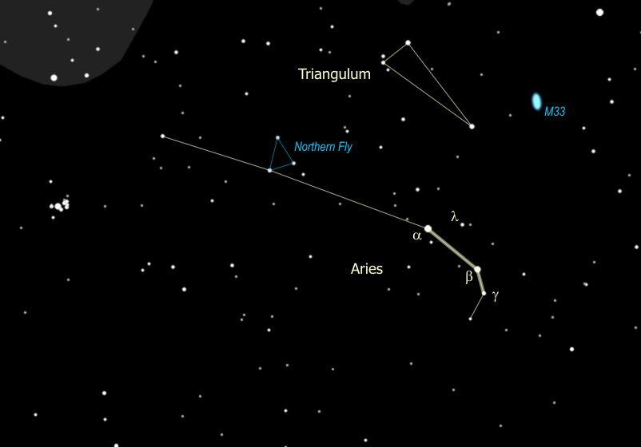

1. The little bitty triangle buzzing around to the left of the bright central stars of Aries used to be a constellation of its own, called the Northern Fly. {Point out the Northern Fly.} Mercifully the fly was gassed and now those stars are officially part of Aries. (There is a Southern Fly - since the demise of Northern Fly the Southern Fly is just the Fly - near the Southern Cross close to the South Pole. We can't see it.)
2. Just to the north of Aries you might notice a distinct, narrow triangle of stars, which happens to be another constellation whose name is, surprisingly enough, Triangulum. {Trace out Triangulum}
3. Aside from being a neat looking constellation, Triangulum is the home of another galaxy, M33. This galaxy is just a little farther from us than the Andromeda galaxy, about 2.4 million light years away, and belongs to our group of galaxies - astronomers refer to this as the "Local Group".

M33 has a reputation for being tough to see and we need a clear, dark sky to really be able to see it. {Point out M33's location} It is so big, faint, and spread out, that it is actually easier to see in binoculars (if we can see it at all) than in a telescope. On a very dark night you might even be able to see it with your eyes alone, by looking just to one side of it (averted vision).

1. The three bright stars of Aries are α (alpha), β (beta), and γ (gamma). If we get the telescope on γ, you can see that it is also a binary, a close pair of clear white stars. If you don't want to bother with the telescope you can spot another double with the binoculars -- mid-way and slightly above the line between α and β is λ (lamda) Arietis, a bright yellow star with a faint yellow companion, just above it. You can spot the faint twin with 10x50 binoculars - if you hold them rock steady. Both of these double stars, γ and λ, are true binary systems -- twin stars that were formed together and are now orbiting one another.

# The Andromeda Legend

Let's go hunt for a galaxy... if it's a good, clear night you can see this one just by looking -- which makes it the farthest thing you can see with your eyes, at 2 MILLION light years away.

1. To find it we start with the Great Square of Pegasus, the four stars here {trace out Great Square} that we found earlier, and Andromeda's head is the Northeast (upper left hand) corner star. The rest of Andromeda is then the figure formed by the two curved lines that radiate Northeast away from that corner {trace out Andromeda}.

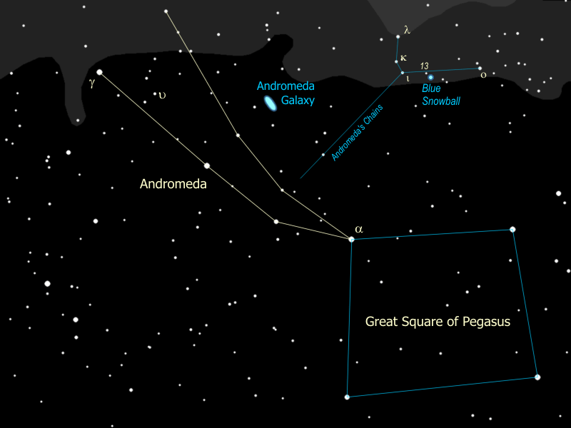

1. Now let's find the Andromeda galaxy. Start with Andromeda's head, then go to the next pair of stars, then to the next pair of stars after that (a little further apart). Follow the line of that pair up and to the right (Northwest) until you get to the next star. Look for a little fuzzy patch just to the right of that star. It sometimes helps if you don't look straight at it, but just off to one side a little bit. When you spot it, just note that you are seeing far beyond our own galaxy, 2 million light years away.

You need a good, dark sky to see the galaxy by eye, but it is easy to find in binoculars. In fact, it looks best in a good pair of binoculars, 10x50 or bigger. It is also an easy target for the telescope. If you look hard in the telescope you might see one or two smaller fuzzy patches near Andromeda. These are satellite galaxies, little galaxies orbiting the big one! Our galaxy, the Milky Way, has satellites of its own, called the Magellanic Clouds. They can be easily seen, looking like detached portions of the Milky Way, but they can be seen only in the Southern Hemisphere.

|  |  |
| --- | --- |
| Andromeda in Telescope | What you're looking at |
| C:\Users\randy\MyWebSite\astronomy\img\AndromedaInScope.jpg | C:\Users\randy\MyWebSite\astronomy\img\andromedaTimMatheson_c2003.jpg |

1. You can use Andromeda to gauge how good your sky is... the clearer the sky, the fainter the magnitudes you can see. Starting with Andromeda's head at a magnitude 2, the brighter curved line is all magnitude 2 stars except the dimmer one right after her head -- that one is magnitude 3. The other curved line is all magnitude 4 stars. The star we used to find the Andromeda galaxy, that's a magnitude 5 star -- notice there is one off to either side of the galaxy. If you can see those two stars you have a really good clear, dark sky. The second pair of stars from Andromeda's head points to the 5th magnitude stars we just found. The first pair of stars points to a similar (and closer) pair of magnitude 6 stars, visible only under the very best of conditions.

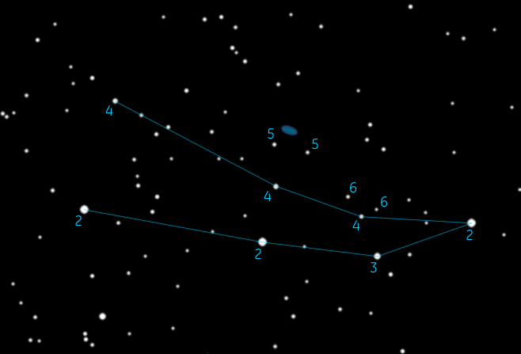

1. We'll swing the telescope real quickly over to the star at Andromeda's left foot (the Southeast one), γ (gamma) Andromedae {point out γ Andromedae}. This is a double star -- can you see the color difference between the two stars? The bright one is yellow-orange, the other is a bluish-green. This is one of the coolest looking doubles in the sky. It's a true double star -- actually it's a four-star system, the blue one is really three stars, but they're too close together for our telescope.

Another star of interest is υ (upsilon) Andromedae, a star very similar to our own sun {point out υ Andromedae}. In 1999 three planets were shown to be orbiting υ Andromedae, making this the first system of planets to be discovered outside our own. (We can't see the planets in our telescope - they were found by calculation from the motion of the star).

1. Andromeda is a princess and she is shown chained to a rock, by her daddy the King. And it wasn't even for anything that *she* did, but we'll get to that in a second. If you follow the chains up to the rock {formed by λ, κ, ι & ο Andromedae, point out the rock} right next to that little bitty star right there {point out 13 Andromedae} is where we are going to focus the telescope. When you look in the eyepiece you'll see two stars and something else... a puff of smoke, maybe. Compare the little puff to the two stars next to it. Can you see a color difference? The puff is actually blue, or blue-green. In fact is known as the Blue Snowball. It's a star like the other two that you see, but this star has blown itself apart!

|  |  |
| --- | --- |
| Snowball in Telescope | What you're looking at |
| C:\Users\randy\MyWebSite\astronomy\img\Snowball_In_Scope.gif | C:\Users\randy\MyWebSite\astronomy\img\NGC7662.jpg |

1. This is another planetary nebula, like the Ring Nebula. They are called planetary nebulae because the disk shape suggested the look of a planet to early astronomers. In fact it has nothing to do with planets at all. This is what's left of a red giant star that, about 1700 years ago, did what all red giants eventually do. When the fuel at the core runs so low that the nuclear reactions can no longer hold up the weight of the star, it all collapses in to the center, which in turn raises the temperature so high that the star blows off its outer envelope of gases, losing much of its mass. This exposes the core to outer space, or, more accurately, exposes outer space to the nuclear reactions going on at the core. The intense radiation from the burning core causes the expanding shell of gas to light up like a neon light, and voila -- the faintly glowing disk that you see here. With a larger telescope you can still see the tiny star that remains at the center of the Blue Snowball -- now a white dwarf.
2. A few billion years from now, our sun will look a lot like the Blue Snowball.
3. So how did Andromeda end up chained to a rock? It all started with her mother, the Queen Cassiopeia, whom we met a little while ago, the Big W over by Polaris.

Cassiopeia had a reputation far and wide for her beauty, and that was not enough for her. She started going around boasting that she was more beautiful than the Nereids, the sea nymphs. When the Nereids caught wind of this they complained to Poseidon, god of the sea, who sent a huge sea monster, Cetus, to wreak havoc in the kingdom Godzilla-style.

1. You can just see Cetus rising on the eastern horizon at this time of the year {trace out the head & body of Cetus} -- pretty terrifying, huh? Well, this is the Kraken from "Clash of the Titans", as the ancient Greeks portrayed him since they didn't have movies let alone CGI. That star right there in the middle of the monster's neck is known as Mira Stella, "The Wonderful Star", technically known as Omicron Ceti.

This is a very famous variable star, changing from bright to dark over the course of about a year. For four months, Mira becomes just visible to the naked eye, then for eight months it can be seen only with binoculars or a telescope. Mira was the first to be discovered of this type of variables, those that take about a year to go through the cycle, hence these are all called "Mira variables". We just happen to be lucky to see it now assuming of course that you can see it, otherwise I skip mentioning it.

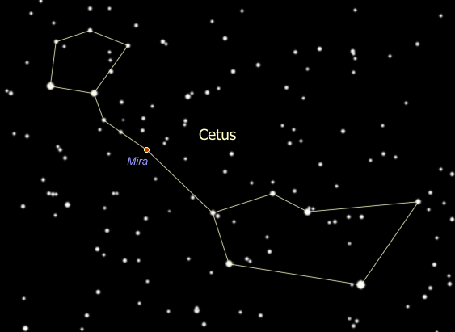

1. All of which brings us to Cepheus the King -- Cassiopeia is his queen, and Andromeda is his beautiful daughter. Cepheus is a house-shaped constellation very close to the Northern horizon at this time of the year. {Trace out Cepheus}.
2. This constellation contains the reddest star in the sky, μ (Mu) Cephei, also called "The Garnet Star" and is located halfway between the two stars at the bottom of the house. It is a red super-giant, 1,500 times the size of the sun. It was considered the largest star known to man until just recently when 3 other stars (which you can't see without a big telescope) were measured about the same size but just barely edge it out. Placed where our sun is, the surface of m Cephei would extend out past Jupiter.

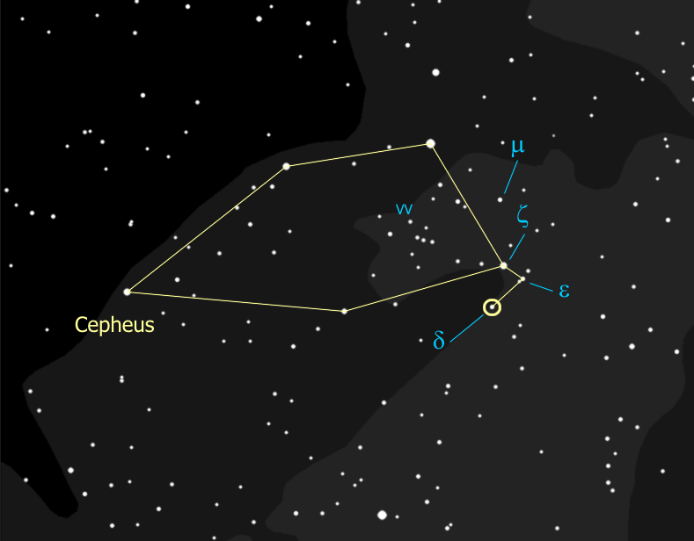

1. If you are ever on an expedition to the planet Mars, you might want to know that μ Cephei is the pole star for Mars. In just about another 6,000 years it will be our pole star, too. That's because our North Pole is actually moving through the sky as the earth wobbles on its axis, a lot like a spinning top does. With the axis wobbling like that, the North Pole is tracing a circle in the sky - it just happens to be passing by Polaris right now.

It is about a degree away from our North Star now and will get about a half degree closer, then will start moving away as it continues on its circle through the sky. That circle will take it almost exactly right down the center of Cepheus, past Deneb in Cygnus, past Vega in Lyra, through Hercules leg and right by his knee, then down past the third star from the end of Draco's tail, Thuban, and back to Polaris. In fact, 3,000 years ago, Thuban was our pole star.

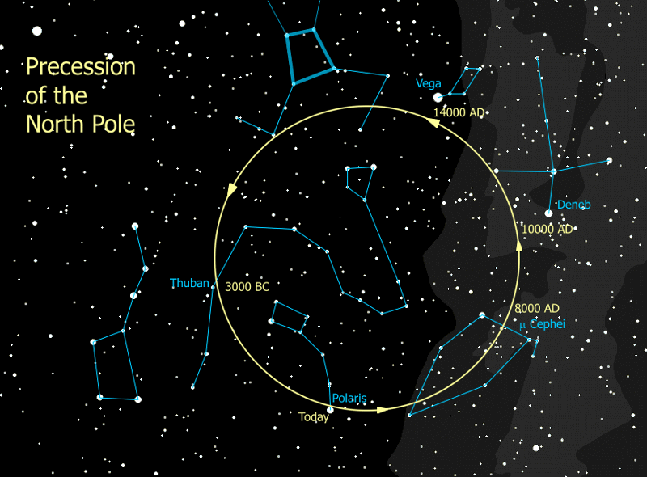

1. Another star in Cepheus is of crucial importance to astronomy -- δ (Delta) Cephei. {Locate δ Cephei.} This star is a "variable", meaning the star's brightness varies over time -- in this case it varies between that of ζ (zeta) Cephei and ε (epsilon) Cephei over a period of five days. How bright is it now -- as bright as ζ, ε, or in between? We will assess again each night that we can during the week.
2. This star was the first of its type to be discovered, hence these variable stars are called 'Cepheid' stars. Cepheid stars have gotten to just the right mass to be unstable - so the whole star is pulsating, the surface of the star is actually rising and falling, with a rhythm that is so precise you could set your watch to it. It was discovered in 1912 that this rhythm depends directly on the true brightness of the star -- the brighter the star, the longer the time between peaks. This discovery, as it happens, rocked the astronomy world. So why was this such a big deal?

Well when a star is closer to us, it seems brighter. When it's farther away it seems dimmer, right? Well we know the true brightness of a Cepheid star, from the cycle time of its brightness. If we know the true brightness of the star, and we measure its apparent brightness, we can figure out the distance to the star. If the star is part of a cluster or a galaxy, this tells us the distance to that entire body of stars. This has been used to find the distances to globular clusters, other galaxies and even our distance from the center of our own galaxy -- 28,000 light years.

In 1924, Edwin Hubble (yes, the telescope is named after him) used Cepheids to measure the distance to the Andromeda 'nebula' (2.3 million lightyears) and proved that it is not another solar system in formation but an 'island universe', another galaxy like our own. This was an extraordinary declaration about the structure of the universe back in 1924. Our whole system of measurement of the universe is built upon the Cepheids as our basic yardstick.

1. Then on top of all that, if we look in the telescope we can see that bright yellow δ Cephei has a beautiful blue companion -- so this is both a variable star and a binary! The yellow star is the variable component, and once was a blue star like its companion. It is now expanding out as it goes through the end-of-life process, and is passing through an unstable phase as it does so. The pair is about a thousand light-years from us, based on the Cepheid period-brightness relationship.

Meanwhile, back in the kingdom, we left Cetus tearing things up, and Cepheus, as the local King, is presiding over this disaster. He consulted his oracle to determine what to do, and the oracle told him that the only way to appease the angry sea god was to sacrifice his daughter, that would be Andromeda, to the sea monster. Sadly, the king chained up his daughter to the rocks by the shore to await the arrival of Cetus.

So here we have them all -- Cepheus the King in a jam, Cassiopeia his beautiful if not terribly bright queen, Andromeda his lovely daughter chained to a rock, and here comes Cetus lumbering like Godzilla with devastation in his wake and our poor little princess in his sites! Are they all going to just sit there watching? Won't somebody DO something?

# Perseus the Hero

Ah, here he comes, the guy we've all been waiting for, the hero of our story, the one, the only -- **Perseus!!**

1. You can find Perseus at Andromeda's feet, and just off the squashed side of Cassiopeia's "W". The triangle that forms his head, though of modest brightness, is an easy feature to recognize, then the rest of the figure, which is pretty bright, is easy to follow from there. {Trace out Perseus}. His right arm is holding his shield, and in his left hand he has the head of Medusa the Gorgon. Being a man of action, he comes directly from his triumphant victory over Medusa and stumbles upon Andromeda, soon to be in the clutches of Cetus the Seamonster.

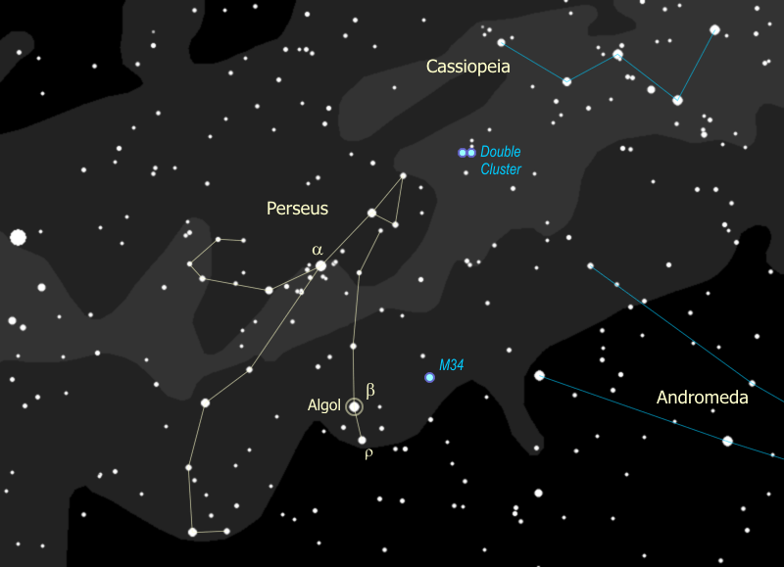

1. The eye of Medusa is well-represented by the star Algol {point out Algol}. Since ancient times Algol has been called the "Demon Star", and in fact the name means "head of the demon". Why? Because this star winks at you. Since stars aren't supposed to do that, it kind of gave people the willies long ago, and they figured it had to be evil or possessed or in some other way just wrong. Normally Algol is nearly as bright as α Persei {point out α}, almost exactly as bright as γ Andromedae. Sure enough, just about every 3 days Algol drops in brightness to that of ρ Persei {point out ρ}. It stays like that for a few hours then goes back to being as bright as α. Any guesses why something like this might happen?

Algol is actually a binary star, and the orbit of the two stars is right in line with us, so each time one star passes in front of the other, the second one is blocked and we see only half the light. This is called an "eclipsing binary". This is not the same as a [Cepheid variable](file:///C:\Users\randy\MyWebSite\astronomy\Fall\Andromeda.html#Cepheid), where the star itself is changing. So what do you think -- is Algol in eclipse right now? We will check on it again when we get the chance and see if we can spot the change.

You might remember Medusa, she was a Gorgon, a monster with snakes for hair and so ridiculously ugly that anyone who looked at her would turn to stone. So how do you suppose Perseus saved Andromeda? That's right, he showed Medusa's head to Cetus, who promptly turned to stone and the princess was saved. Lucky he just happened to have that head on him, not usually something you carry around.

1. If it seems to you that there are an awful lot of stars around α Persei that's because there are... that is a true glactic cluster of stars, all formed together, and they look spectacular in binoculars. You can spot another cluster in Perseus half way between Algol and γ Andromedae -- an easy target for binoculars and with a really dark sky, one you should be able to spot just by looking. This is M34, about 1500 light years away and very similar in nature to the Pleiades or M36 in Auriga, although it's a little older than they are, at about 100 million years.
2. But the best cluster in Perseus is really two clusters, the Double Cluster halfway between Perseus and Cassiopeia. You can find it easily in the binoculars, and this is definitely worth getting in the telescope. The one closer to Cassiopeia called "h Persei" and is "only" about 6 million years old. The one closer to Perseus is called "χ (chi) Persei" and is 12 million years old. How can you tell that χ Persei is older? If you look at it carefully in the telescope you might be able to spot 3 red giants in χ Persei, whereas h Persei has no stars old enough to have evolved yet into red giants.

|  |
| --- |
| Double Cluster with χ Persei to the left and h Persei to the right |
| C:\Users\randy\MyWebSite\astronomy\img\doubleCluster2.jpg |

1. So... do you think Perseus was just walking around carrying a Gorgon's head? How does a self-respecting career hero get around? Well, this one was travelling in style, on the back of a winged horse named Pegasus. And yes, Pegasus has his own constellation too.

To find Pegasus we start with the Great Square of Pegasus {point out the Great Square} that we used to find Andromeda. Well, this actually is Pegasus, or rather it's the body of Pegasus. His head comes off the corner opposite from Andromeda {point out the head}, as you can see he's upside down, and so his front legs come off the corner that's north of the head. We only get to see the front half of Pegasus, much the same way we only get to see the front half of Taurus.

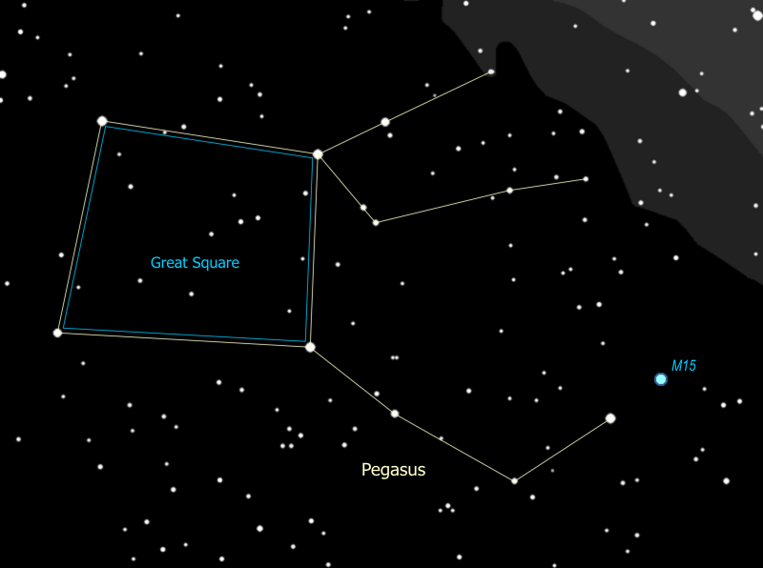

1. If you follow the line of Pegasus' head you can see a star cluster of a completely different type - a globular cluster - looking like a puff of breath from the winged horse. Globular clusters are rare - only about 150 are known, and they are completely different from open clusters like the double cluster we just looked at.

Remember χ Persei is about 12 million years old, M15 is estimated at about 12 BILLION years old, making it so old that it formed before the disk of the Milky Way galaxy formed! While the χ Persei cluster has maybe 300 stars in total, M15 has several hundred *thousand* stars. χ Persei is about 7,000 light years away and is big for an open cluster at about 70 light years across, while M15 is 35,000 light years away and 175 light years across.

So globular clusters are much bigger than open clusters, much farther away and they are much much older - some are nearly as old as the universe!

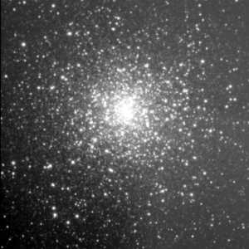

Well, here we are back at the Great Square, the centerpiece of the autumn sky, and that concludes our Autumn Sky Tour. For those who are interested, we may go back and pick up some of the fainter or more obscure items that I deliberately skipped. With Auriga and Taurus on the rise, we may spend some time with them, particularly the Pleiades and the Hyades star clusters. These are described in the [Winter Sky Tour](file:///C:\Users\randy\MyWebSite\astronomy\Winter\winter.html).

Especially if we have a monster telescope to work with, the hard core among us may pursue additional targets. In particular we might hunt down two additional planetary nebulae, the Helix and the Saturn Nebula, which I passed over because we've already have two others in the fall sky, the Ring Nebula and the Blue Snowball, both of which are better. We might also go back for the globular clusters M2, and M72, and the galaxies M33 and M74 all of which I normally skip. At this point though, we covered so much ground that the tour group's brains are in vapor lock from information overload on top of the day's activities, so this is a pretty good time to call it quits.

# Tell Time by the Big Dipper



Using the Big Dipper to tell time (by the line from the pointer stars to Polaris) is easy.

* It's a backwards (counter-clockwise) running 24-hour clock, because the earth turns west to east a full turn every 24 hours, and
* It runs fast. Due to the earth's yearly orbit around the sun, it gains 24 hours each year.

So to use the clock you only need to do two things.

* Remember the 24-hour clock face, shown above, and
* Adjust the 24-hour (midnight) mark on the clock to the current date. 24 hours in 12 months is two hours every month, so shift the midnight mark up by two hours (counter-clockwise) on the clock each month, or a half-hour each week. Some key dates to remember are shown on the drawing.